1. Apply below mentioned group polices result screenshot is must (7 Marks)

|  |  |
| --- | --- |
| Organizational Unit | Group Policy |
| IT | deny access to registry & task manager |
| Sales | Deny access to CMD and control panel user  settings |
| HR | Deny access to registry and control panel |
| Domain | Domain password policy is user account should lock after 3 wrong user attempts. After 15 mins user account should be unlocked |

Note: Verify the Output and submit screenshots of the Output

Step 1:- create OU and drop the User In OU

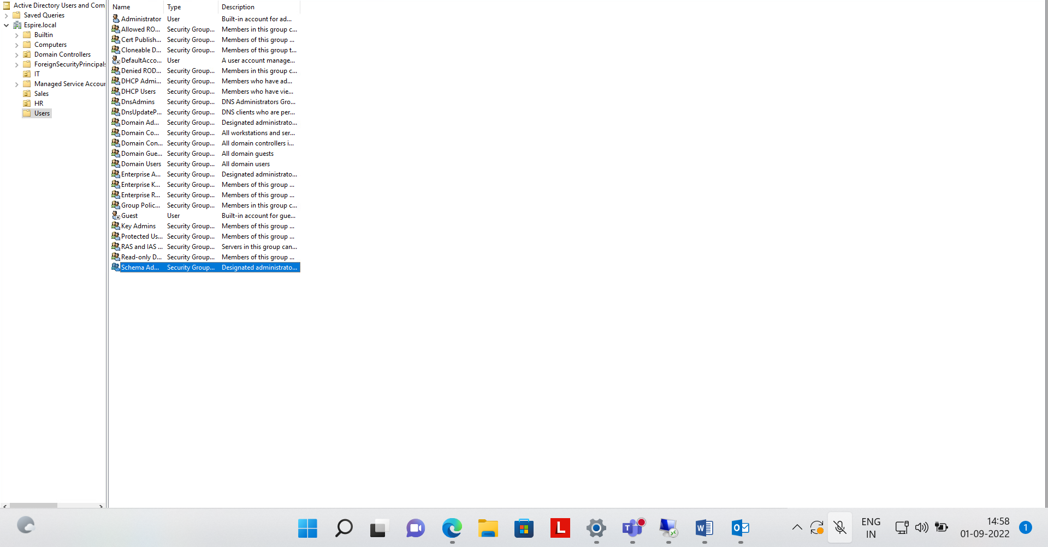

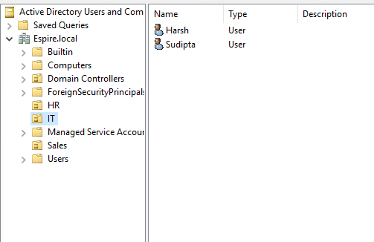

Step 2:-Now create the GPO in the Domain1

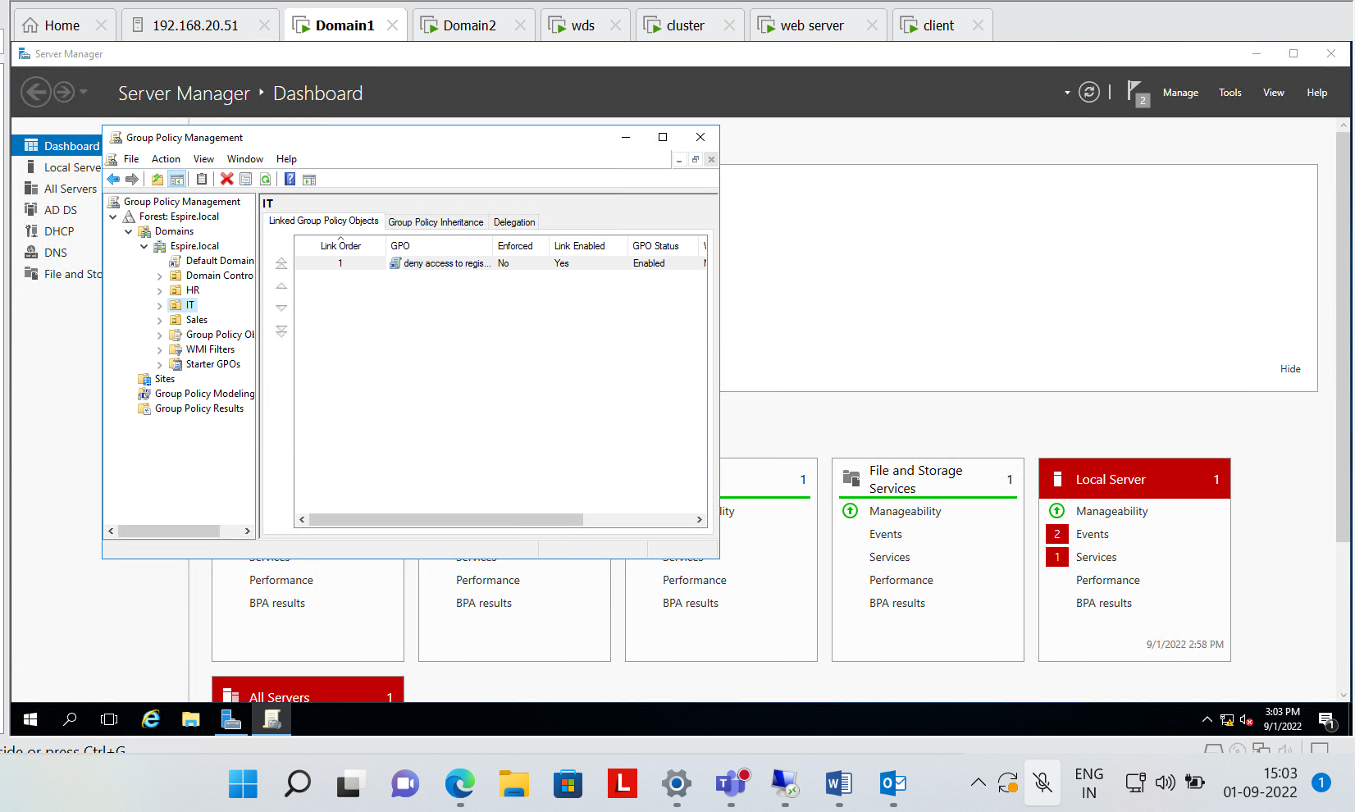

Step 3 :- enable to deny access to task manager in IT

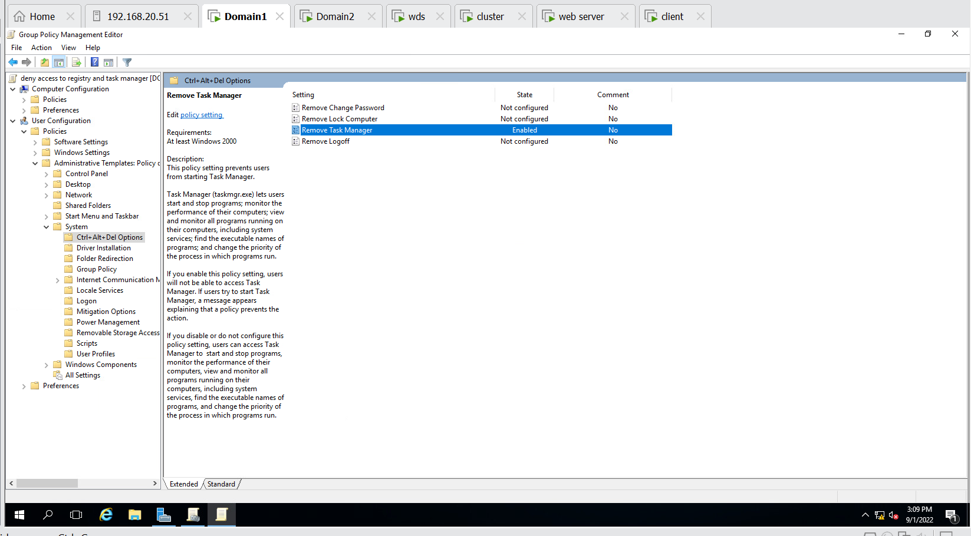

Step 4: enable to deny the access to registry

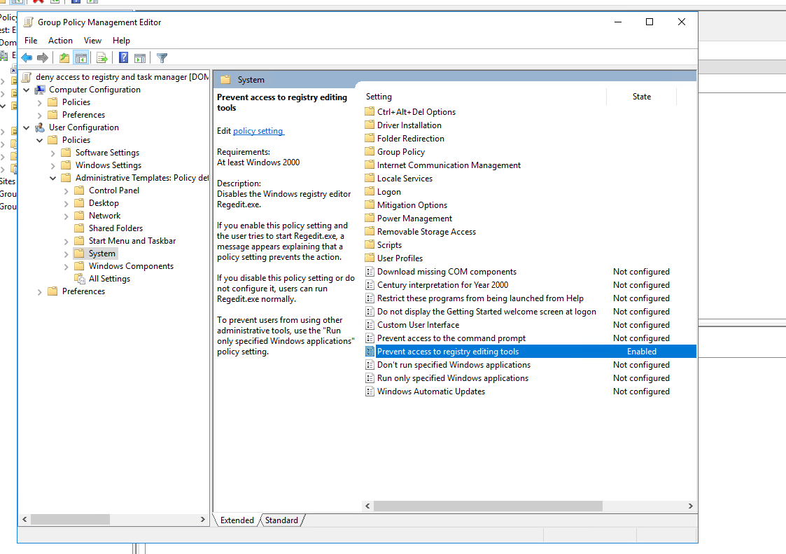

Step 5 :- deny both the task manager and registry in IT(OU)

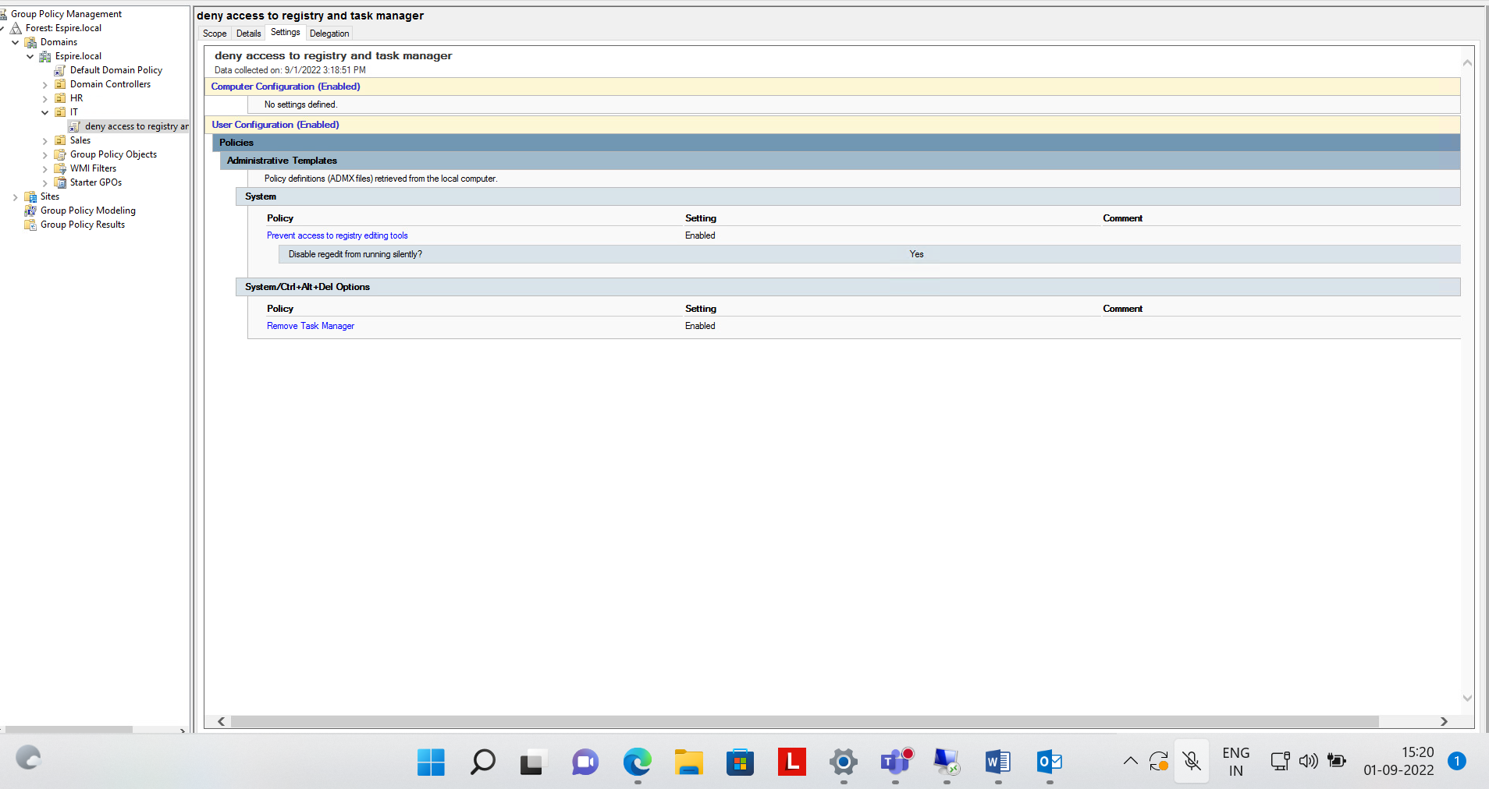

Step 5 :- now we will go the client machine and switch the user and signup with user of IT and check to run the task manager and registry…

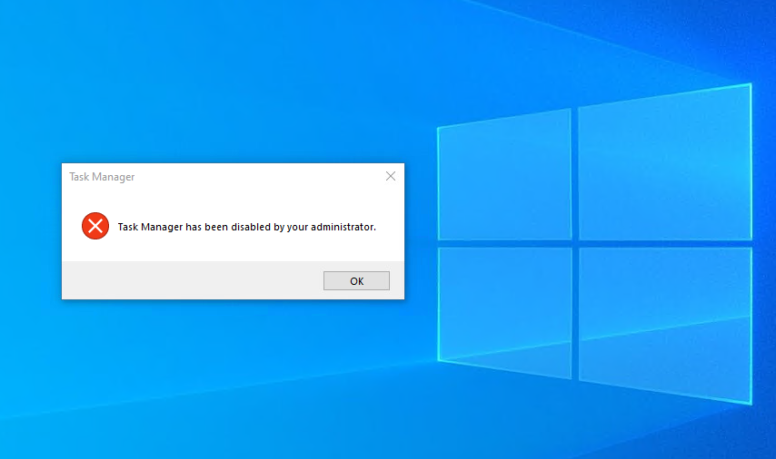

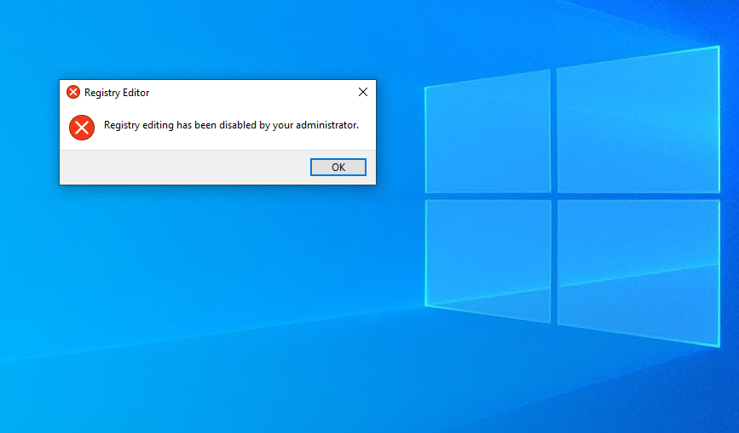

Step 6: deny the access to control panel and cmd in OU(sales)

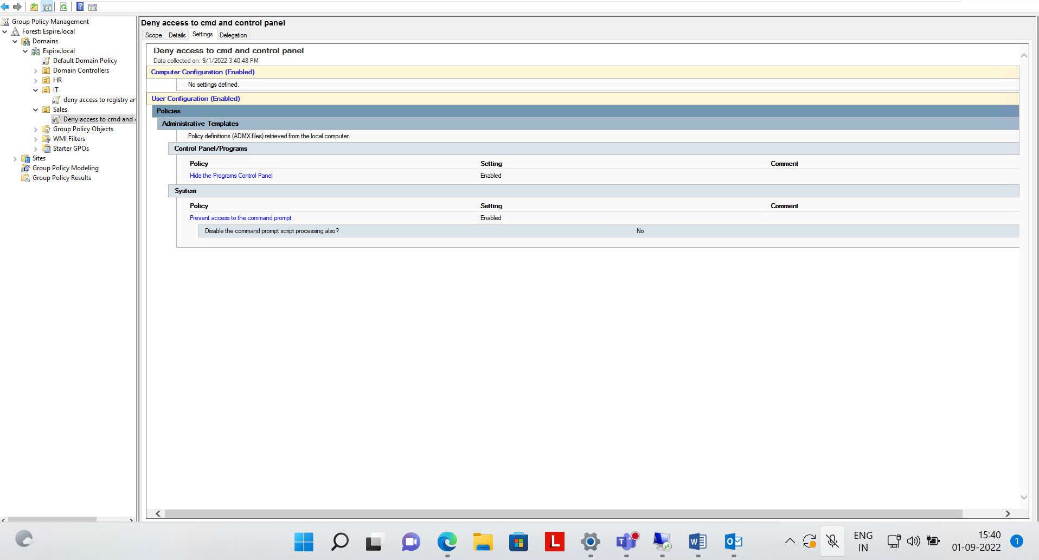

Step 7 :- Successfully enabled to deny the control panel and cmd in OU(Sales with Nikhil User)

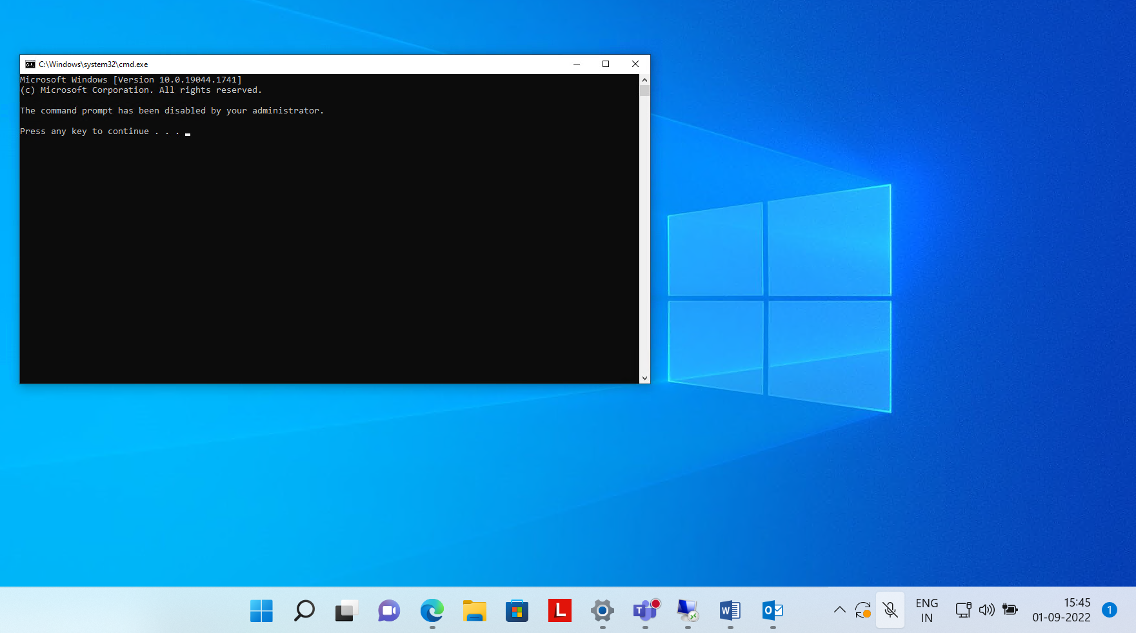

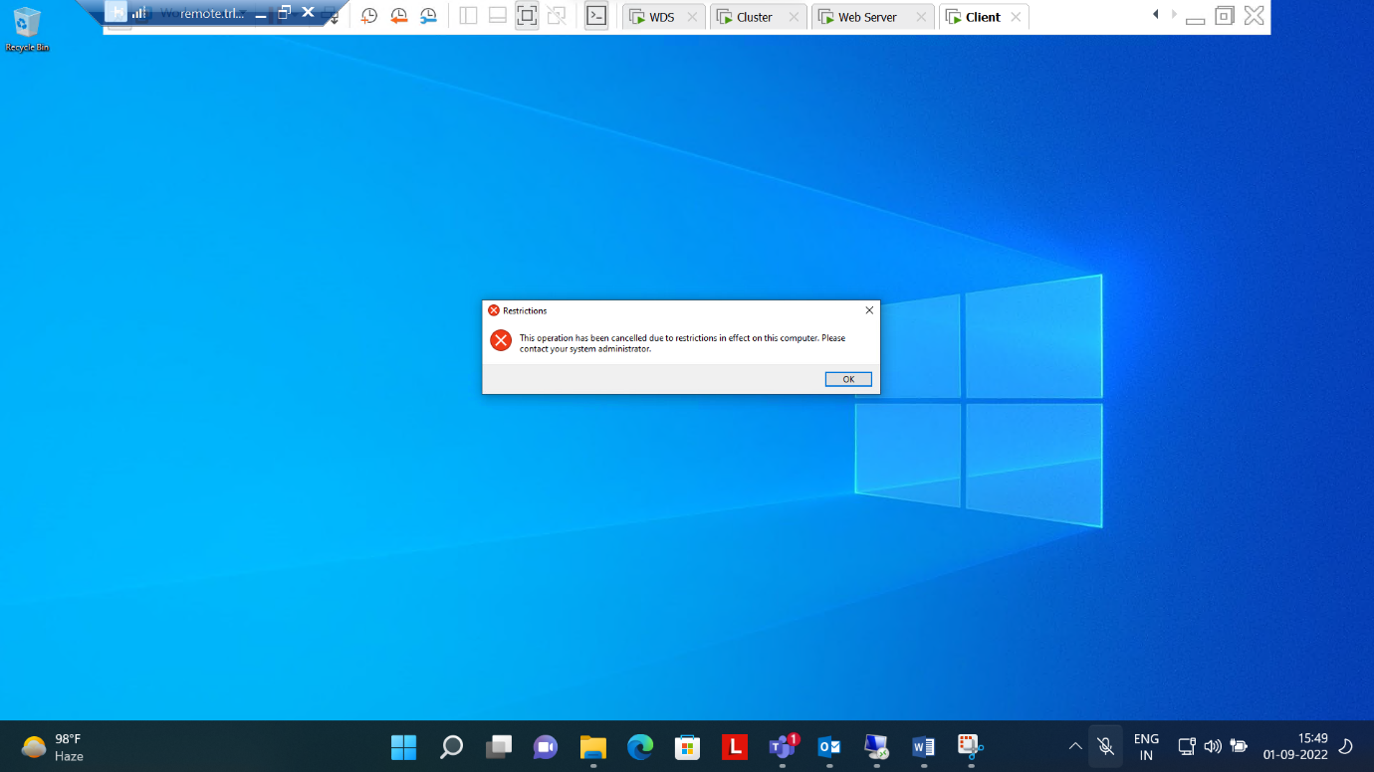

Step 8:- Enabled to deny the access the Control panel and registry in Hr (OU)

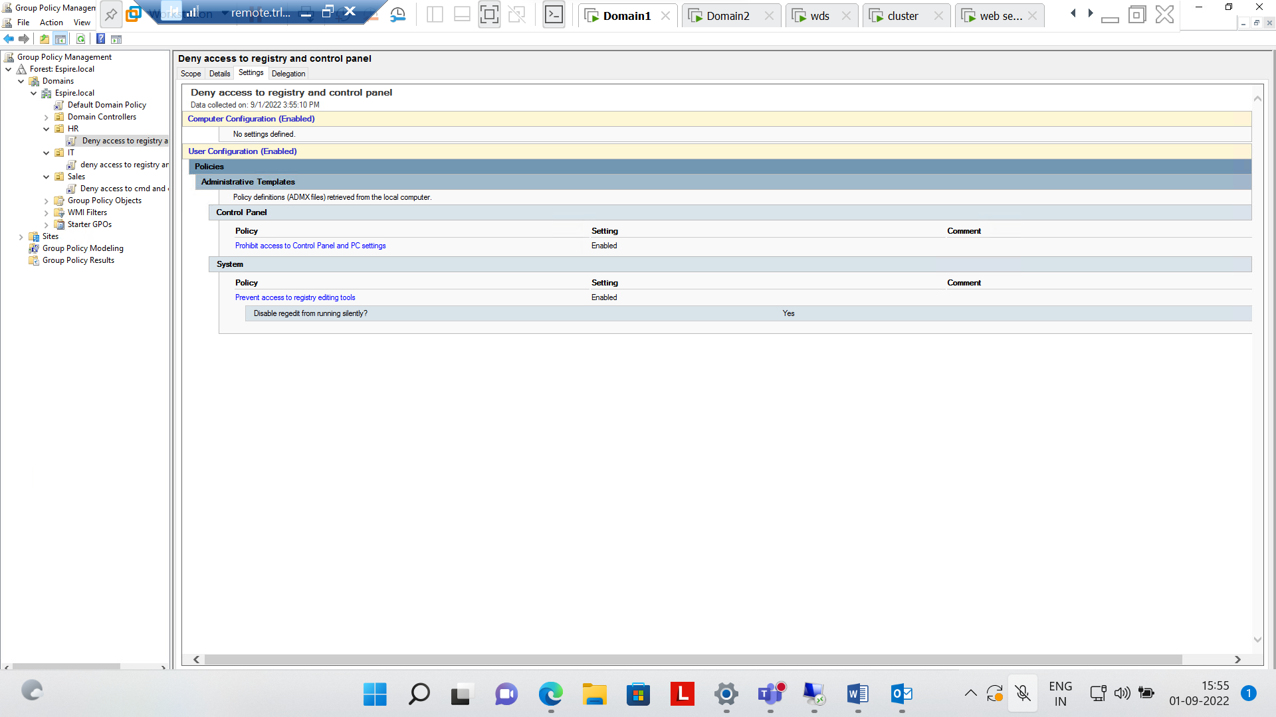

Step 9:- Successfully enabled the cmd and control panel by user indu in OU(HR)



Step 10:-Now enable the setting of lookout the screen if we attempt three wrong password….

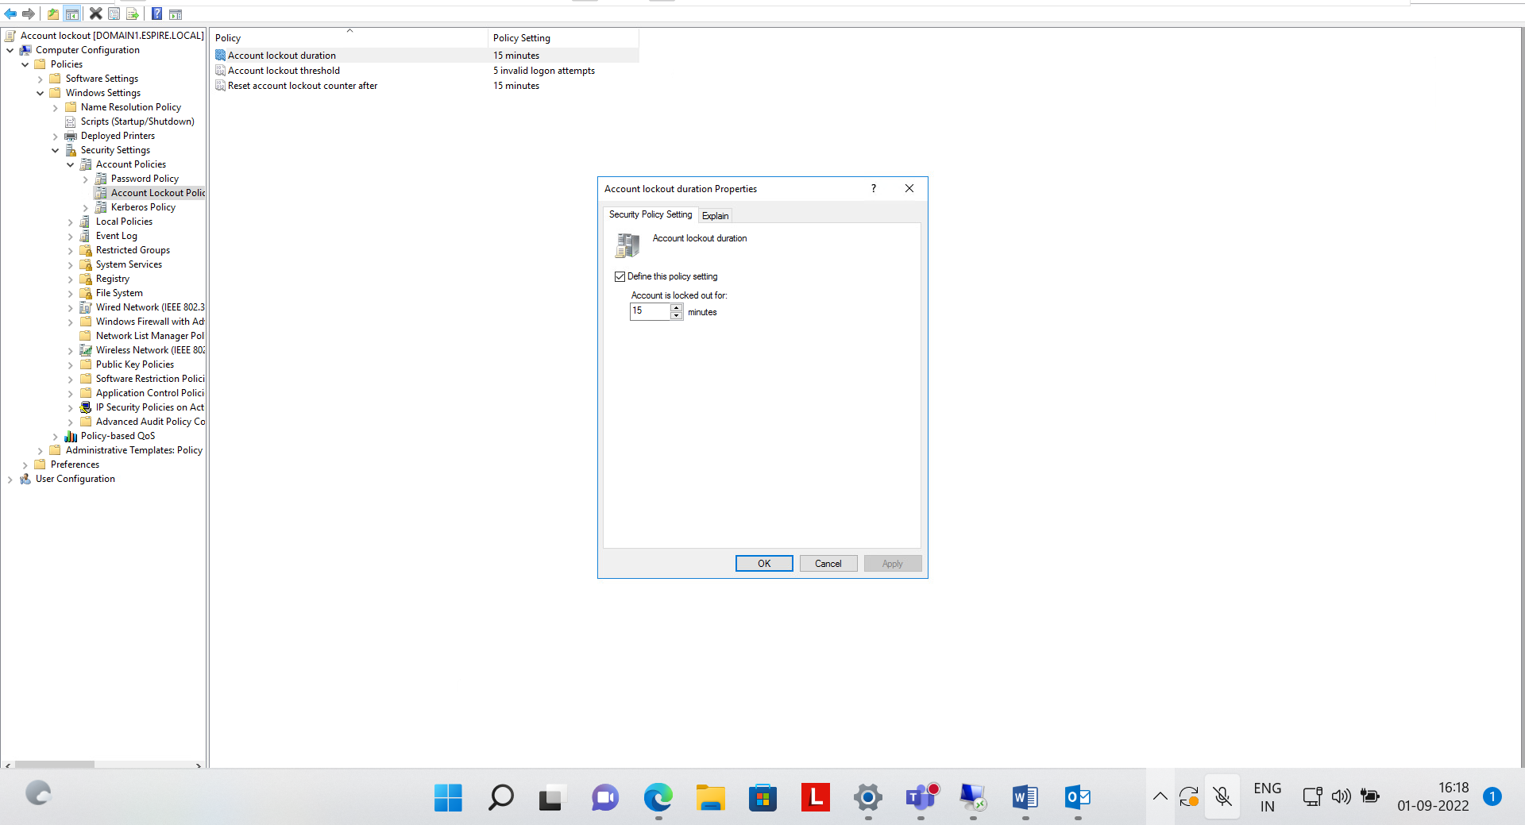

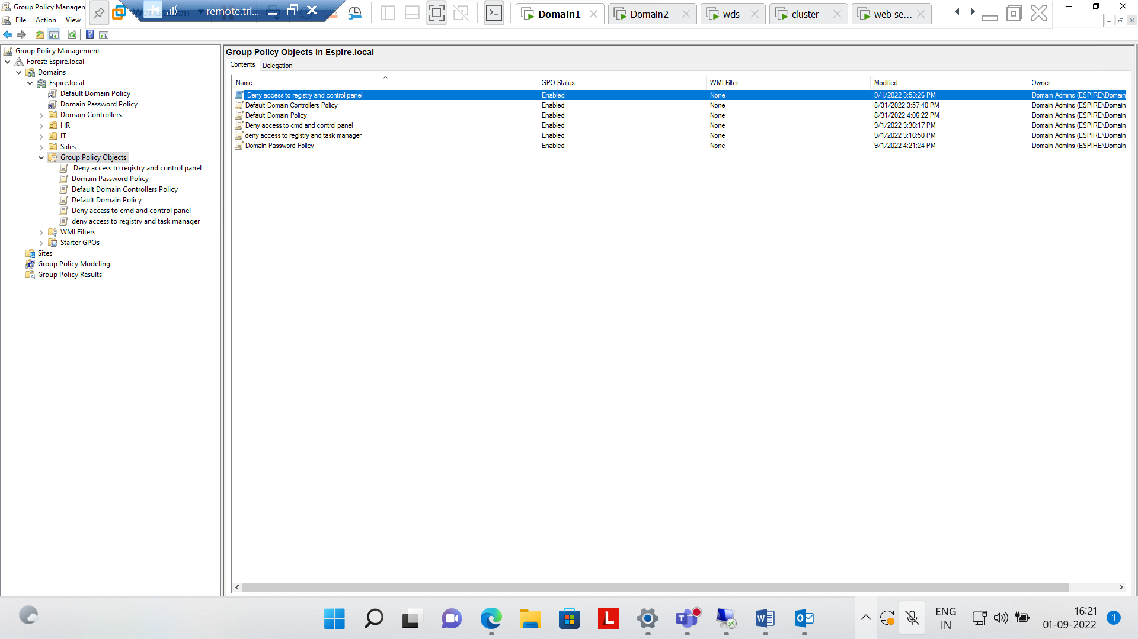

1. Apply below mentioned configuration using FSRM. Create a folder for IT as mentioned below. Implement and apply the following FSRM Policy. (5 Marks)

|  |  |
| --- | --- |
| Folder | FSRM policy |
| IT | 10 MB hard Quota, can’t save  mp4 files |

Step 1:- Now make a folder IT in Local Drive of Domain1

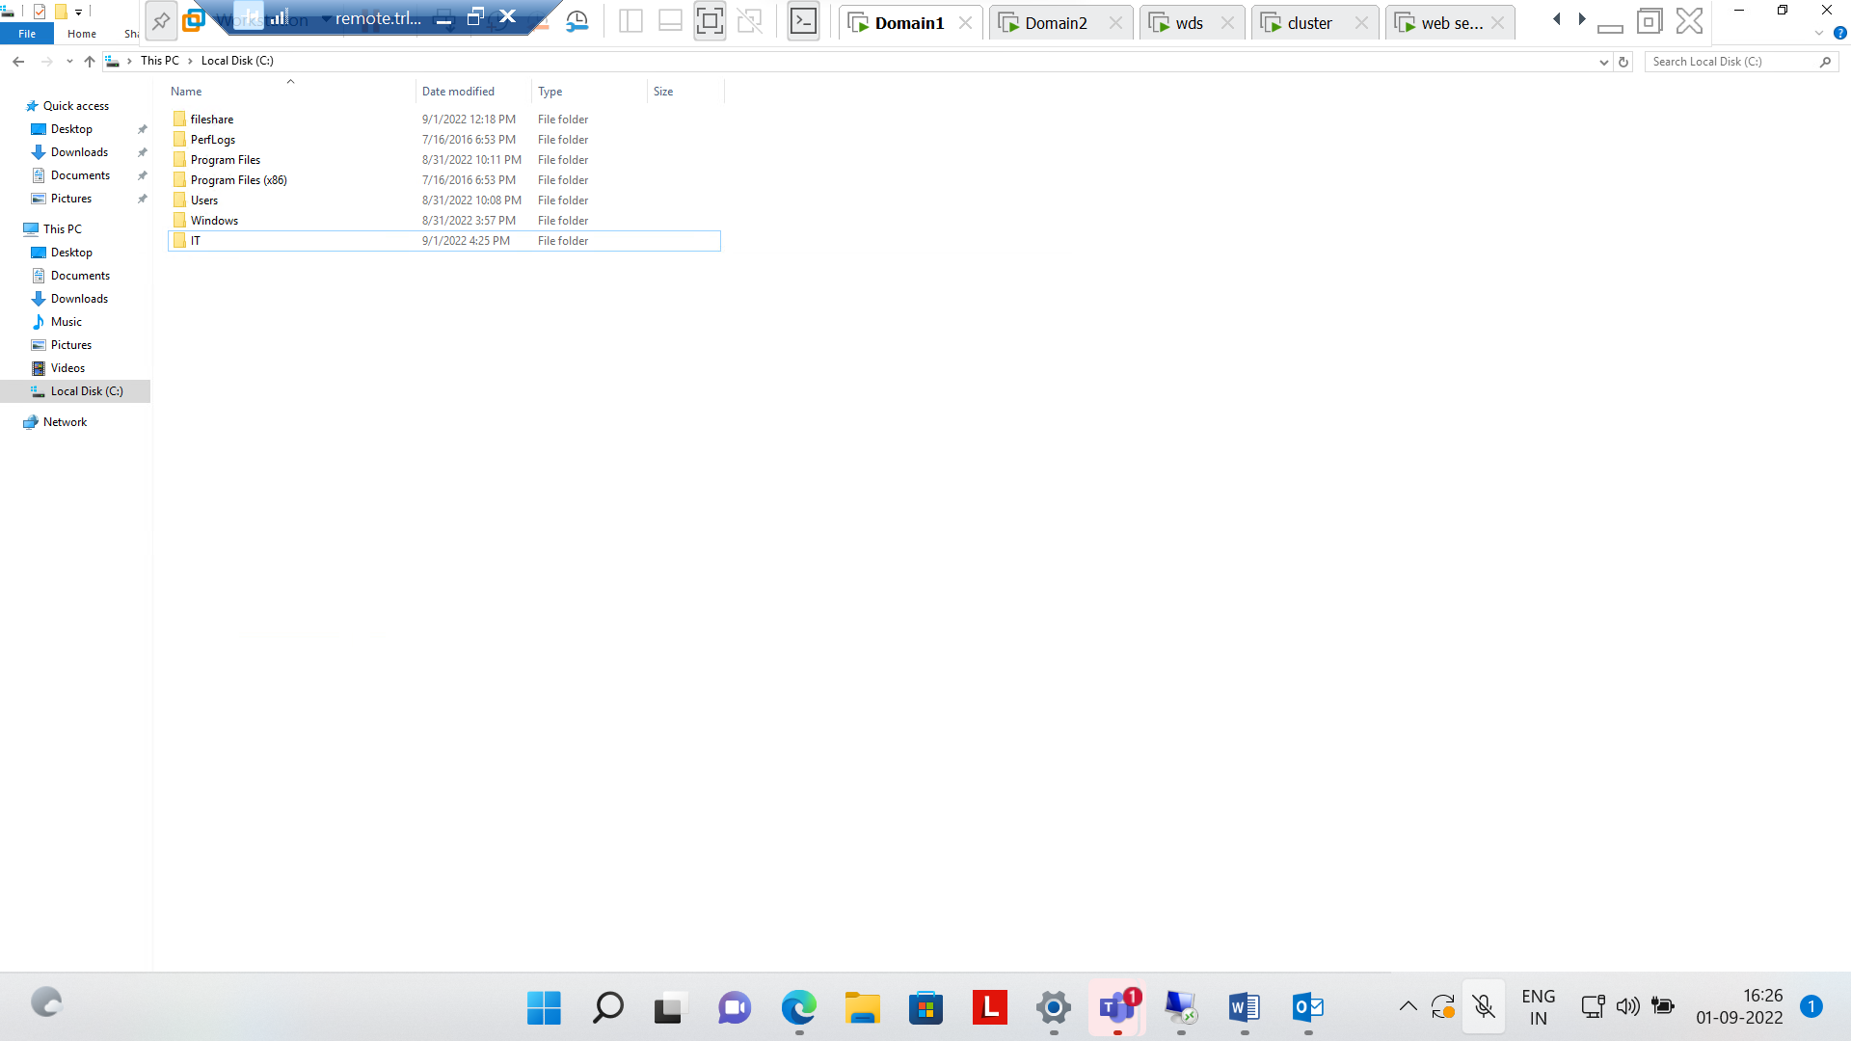

Step 2:-Go to file server Resource Manager and create a new quota of 10mb

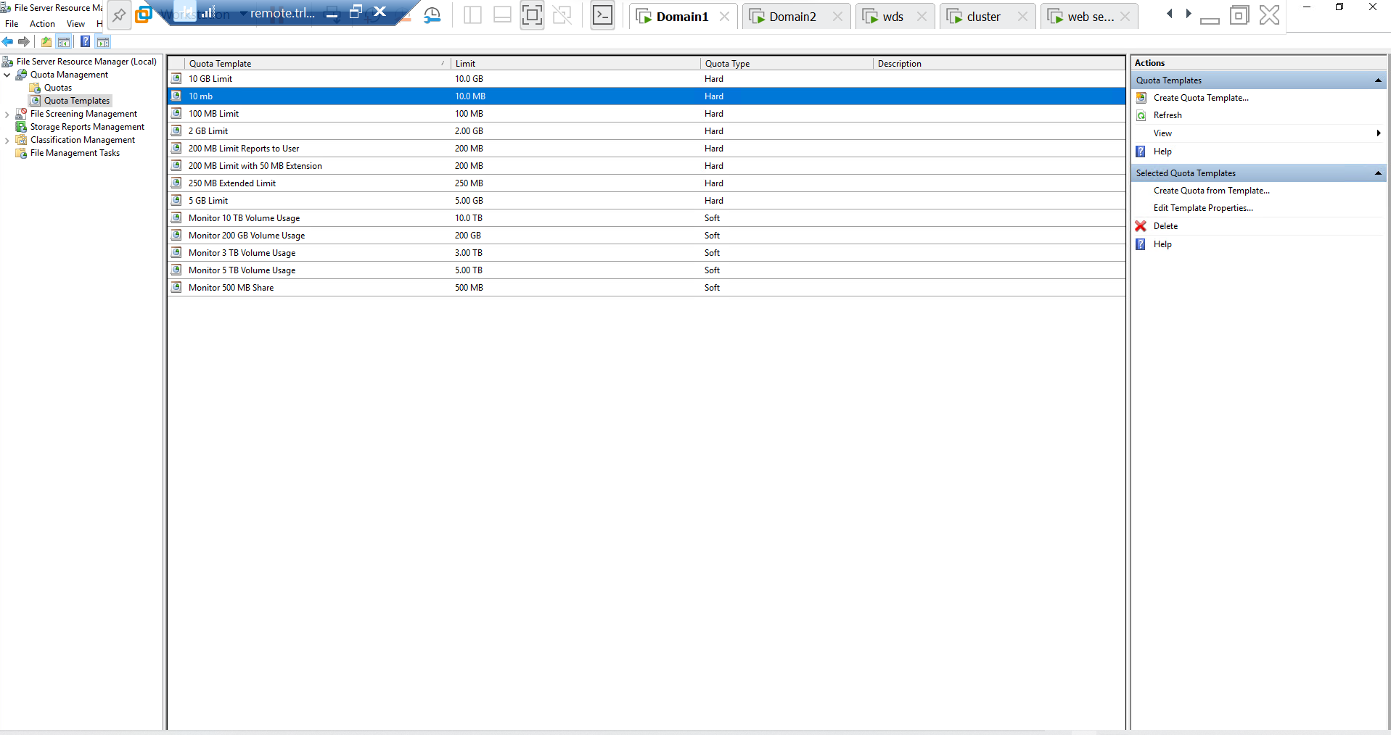

Now go to file screen template and blocked the audio and video files on domain1

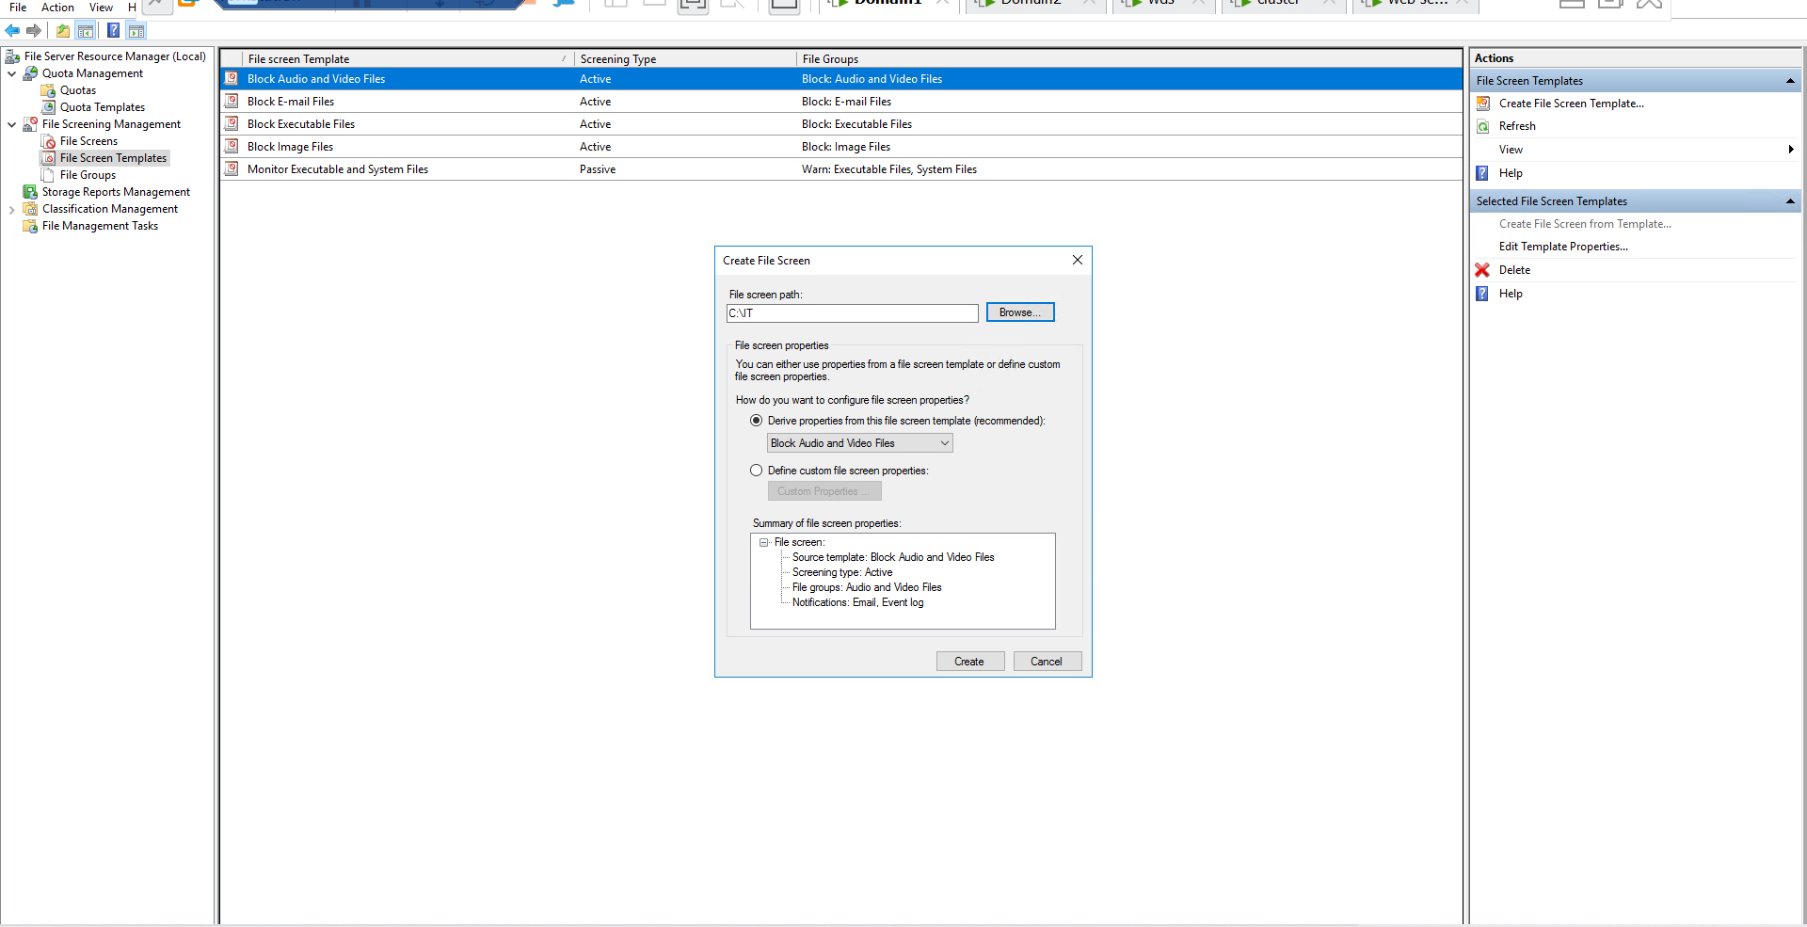

Now make a file in IT and save it as .mp3 extension then it will show the restriction…......

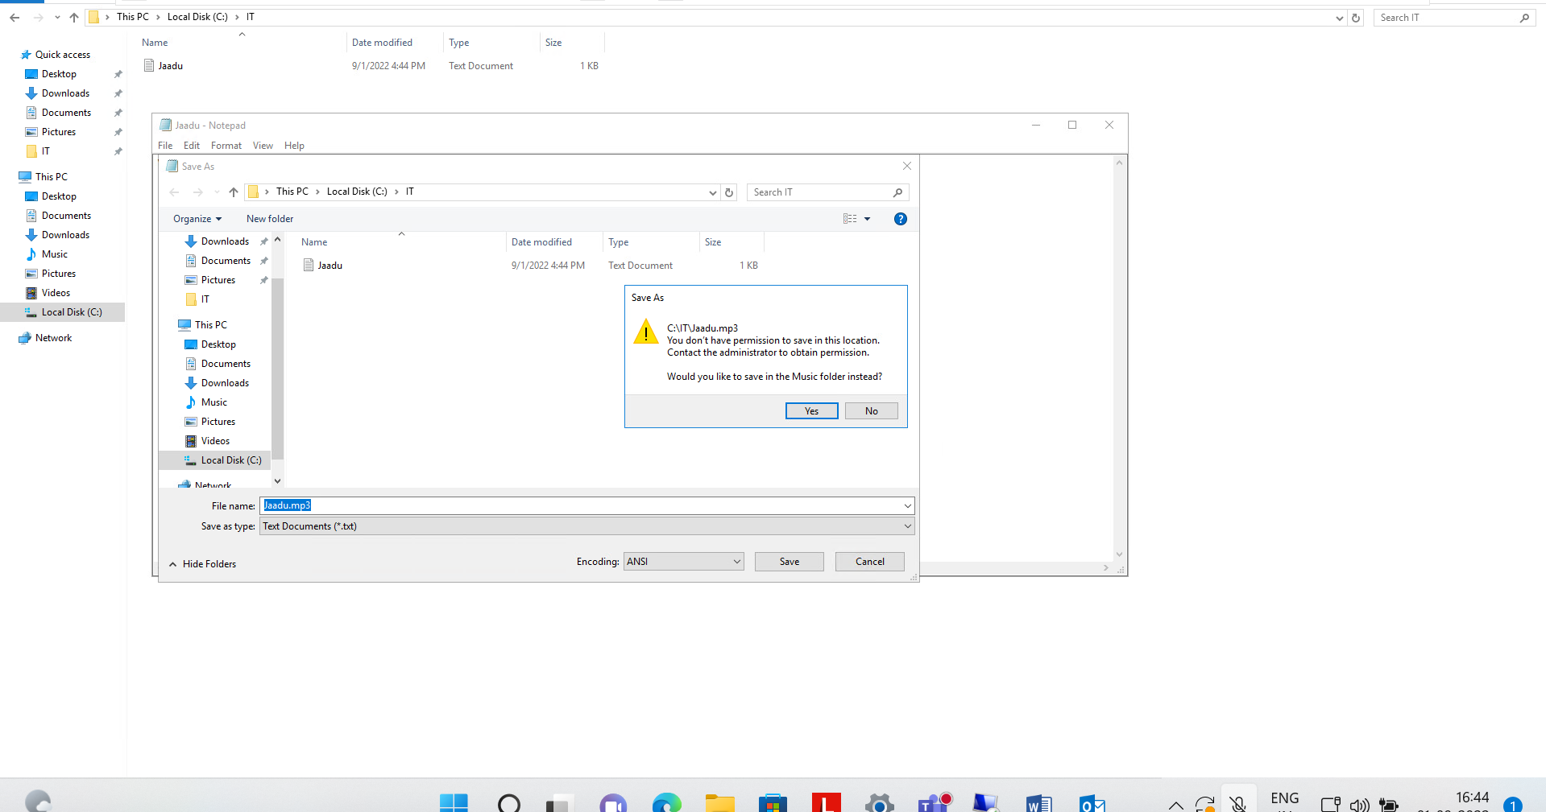

Then we set the Quota only of 10 mb

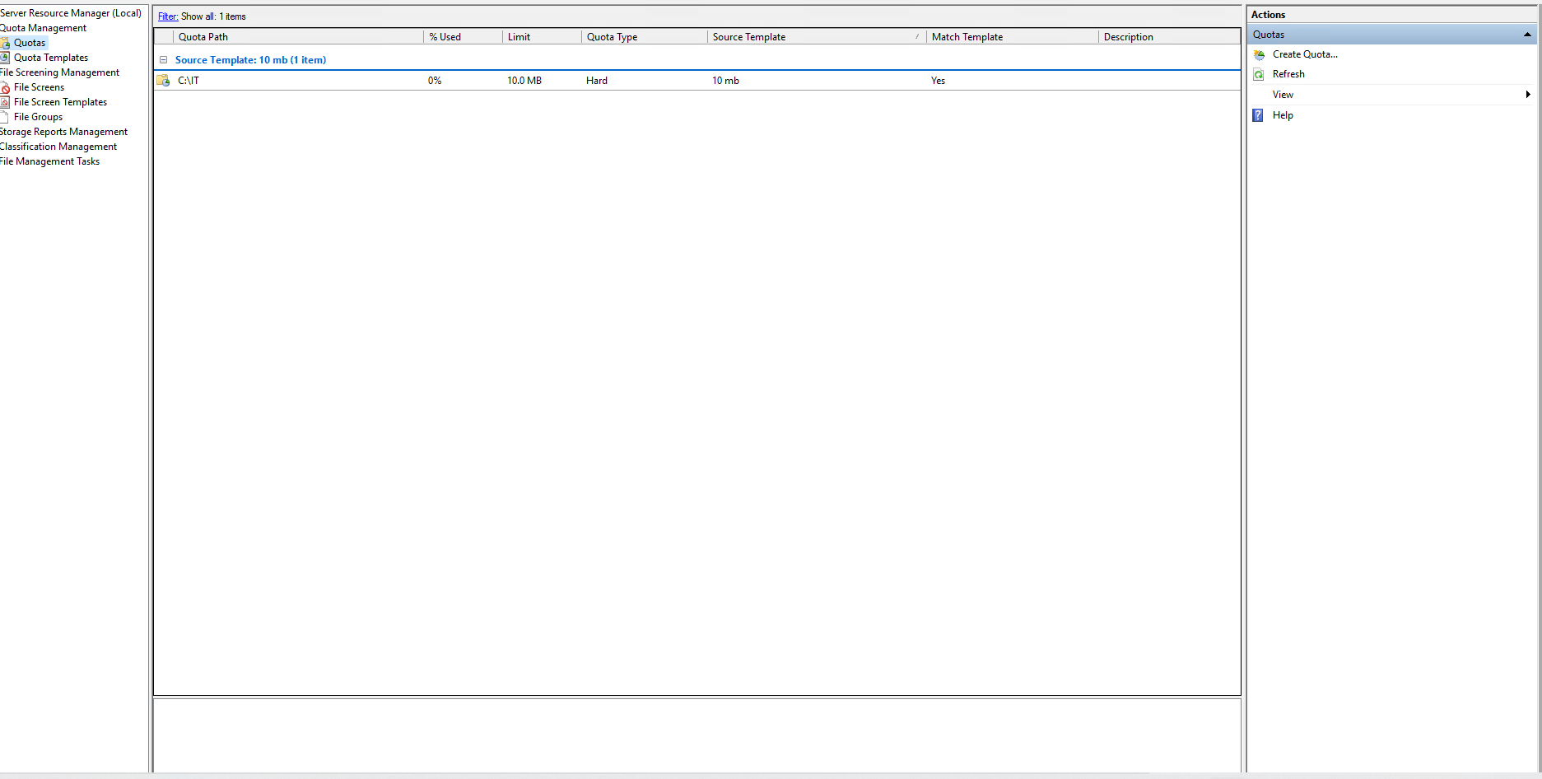

Now Copy a File which is greater than 10 mb in space in IT folder and it will show the restriction…..

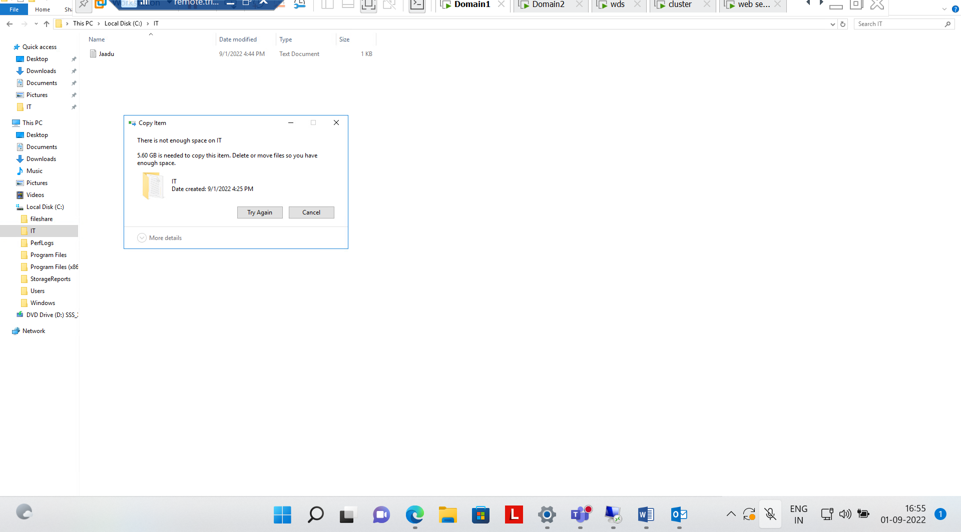

Question 3} Perform Backup of a Server Folder into a shared folder in your Client Machine. Delete your server folder and Recover the folder from that backup.

Step 1:- Now make a folder Fileshare on domain C drive and make a file in it….

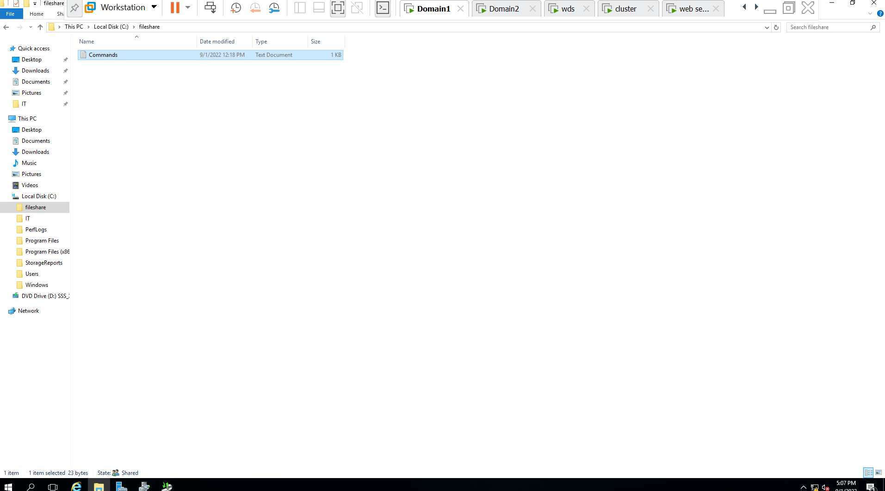

Step 2:- Now make a folder Backup Folder in C drive of Local disk and delete the file of fileshare folder in Domain 1 and schedule the backup with window server backup….

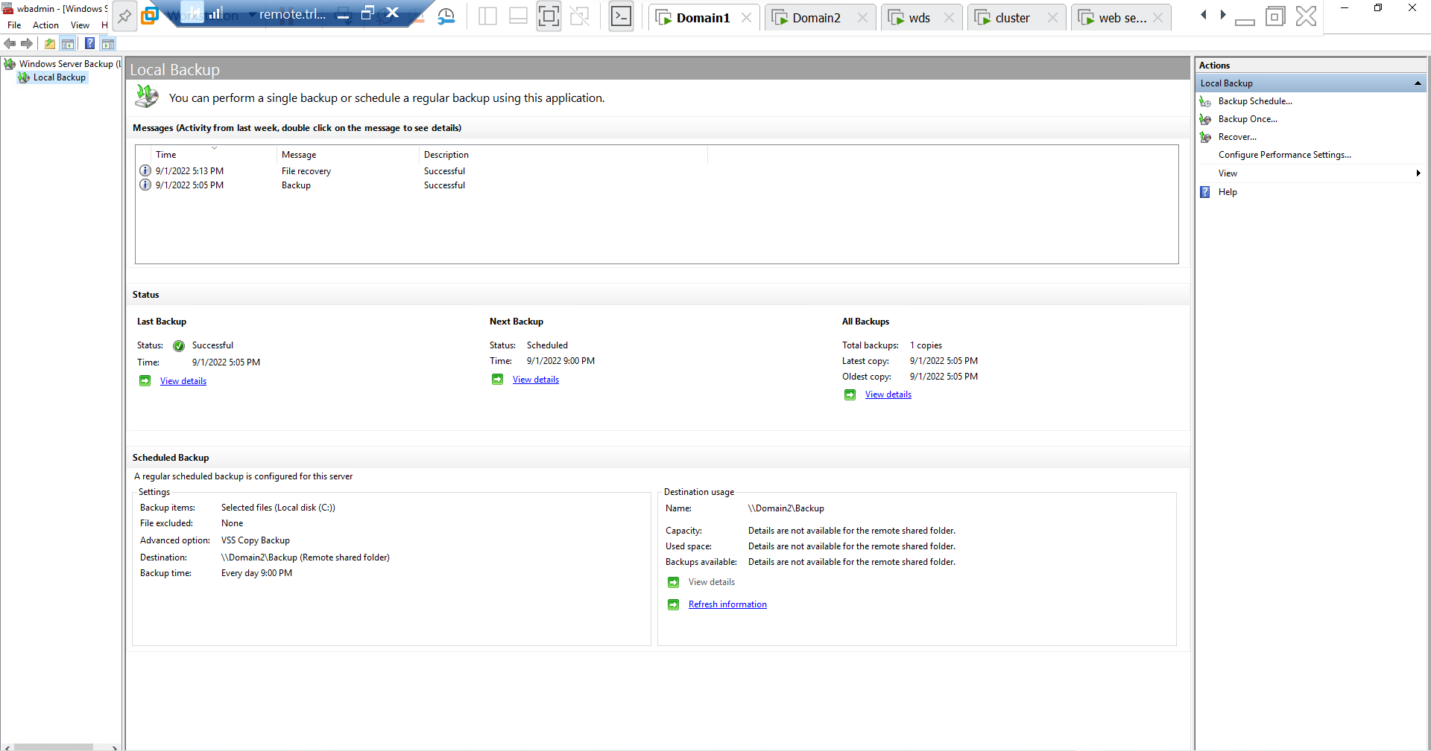

Step 3:-Now we can see the backup in domain 2 in backup folder

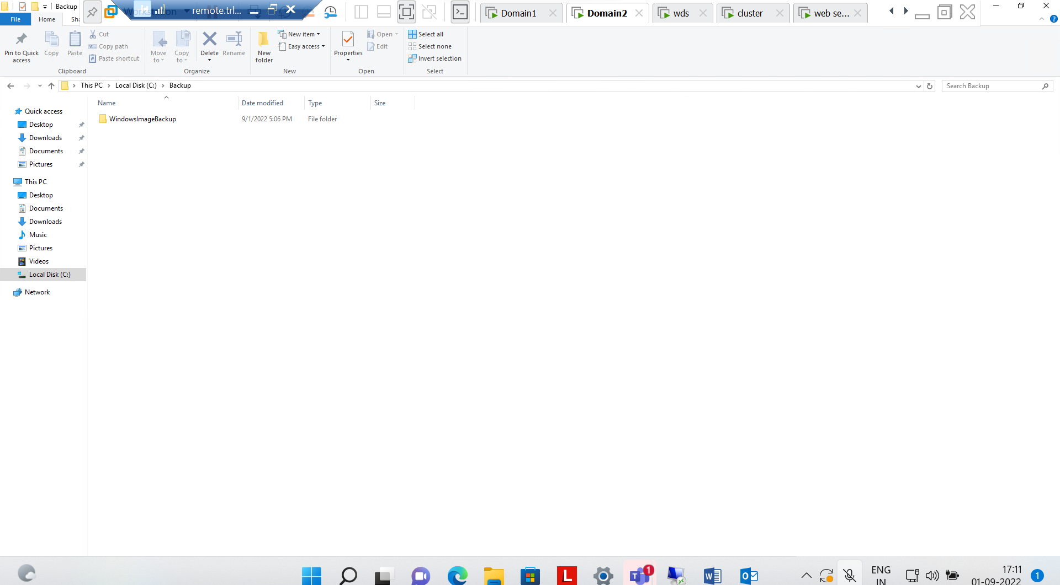

Delete the file in the Domain 1 and now we will recover it…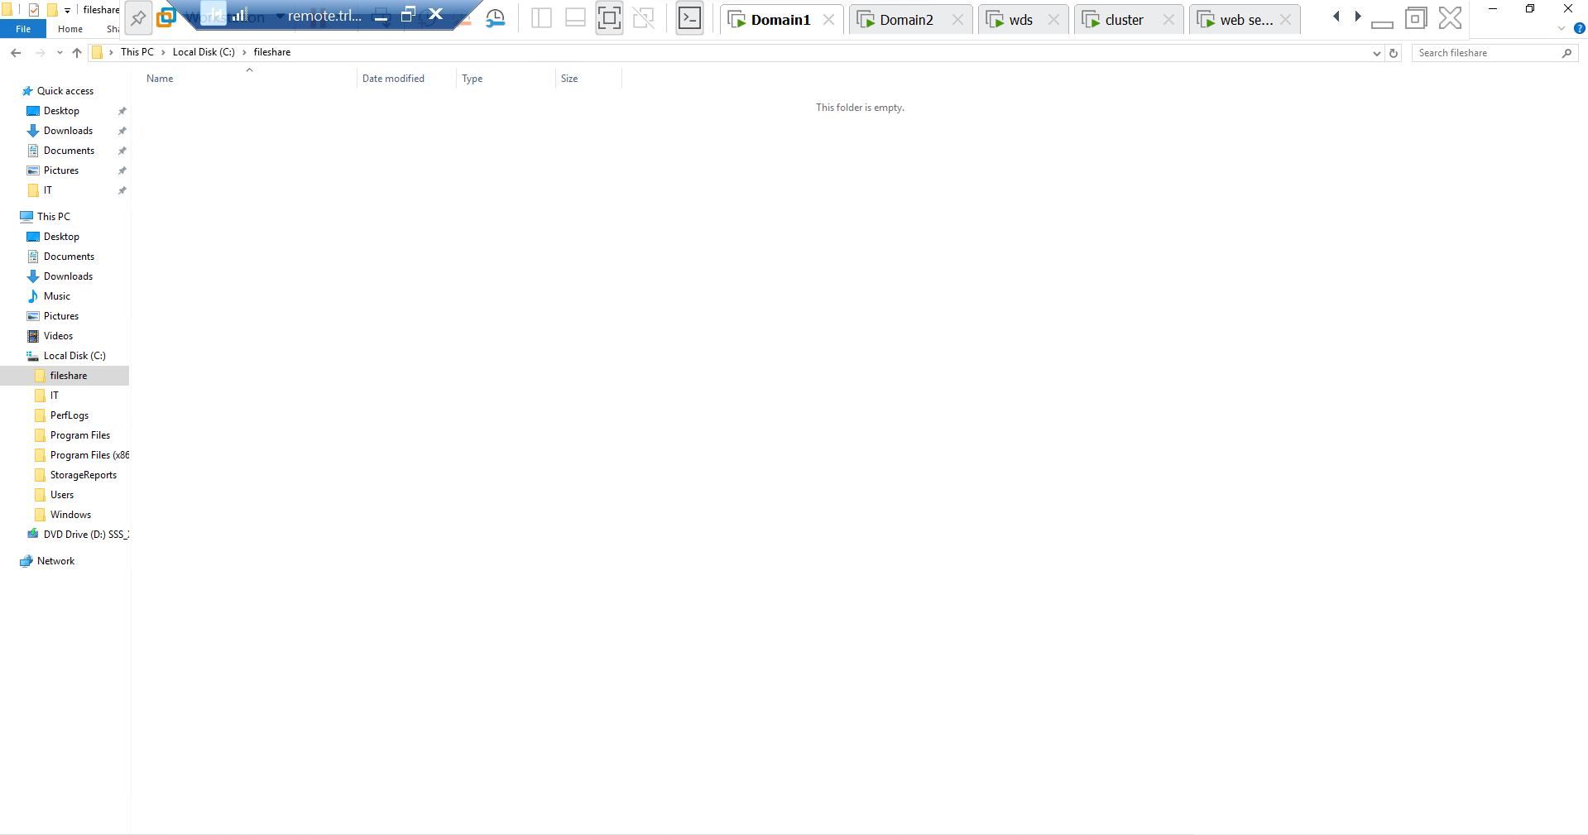

4} Implement network deployment of a Windows 7 OS to clients. Ensure you don’t miss to capture the screenshot of IP address display in the client when loading from WDS. Verify if it is working (Verify if it is reaching to 1% progress of OS installation).

Step1:- Install the window deployment services in wds

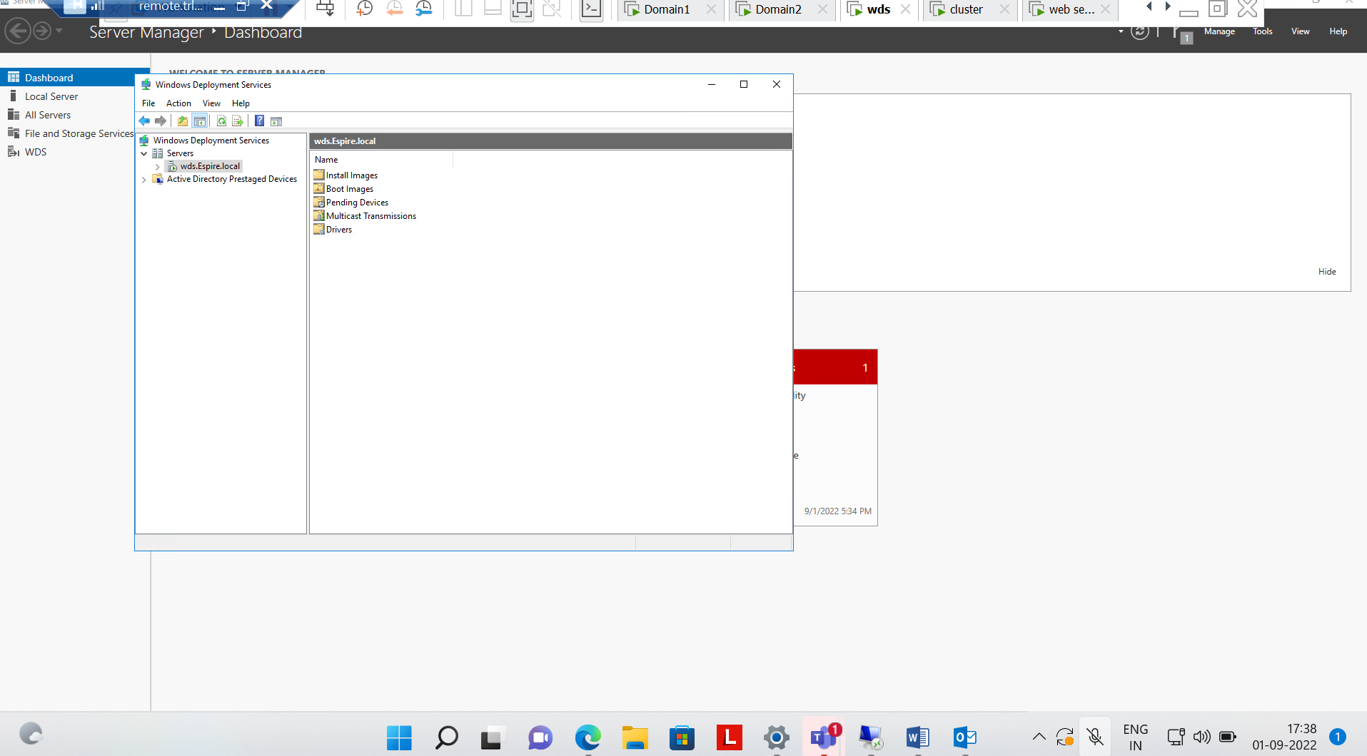

Step2:- now Add Boot images of window 7 ultimate in it..

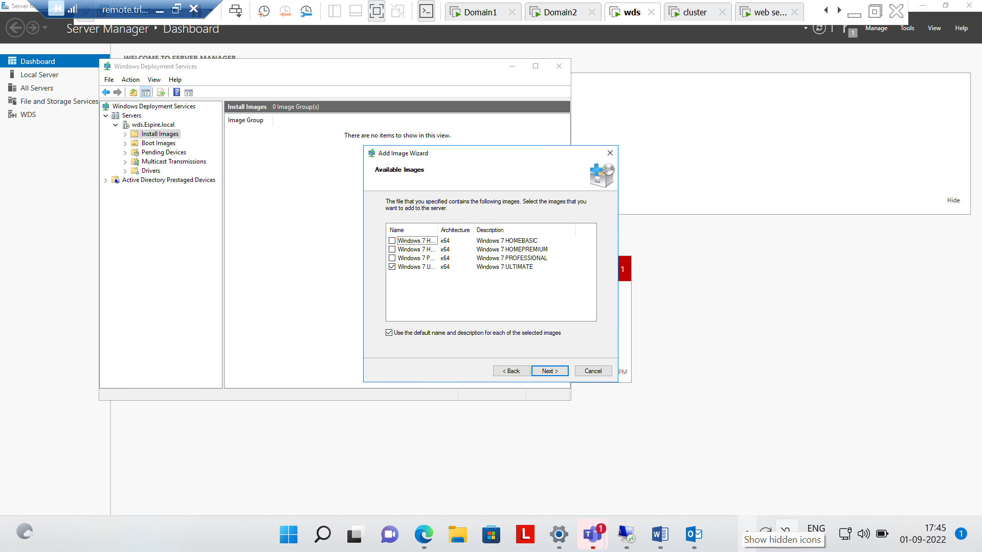

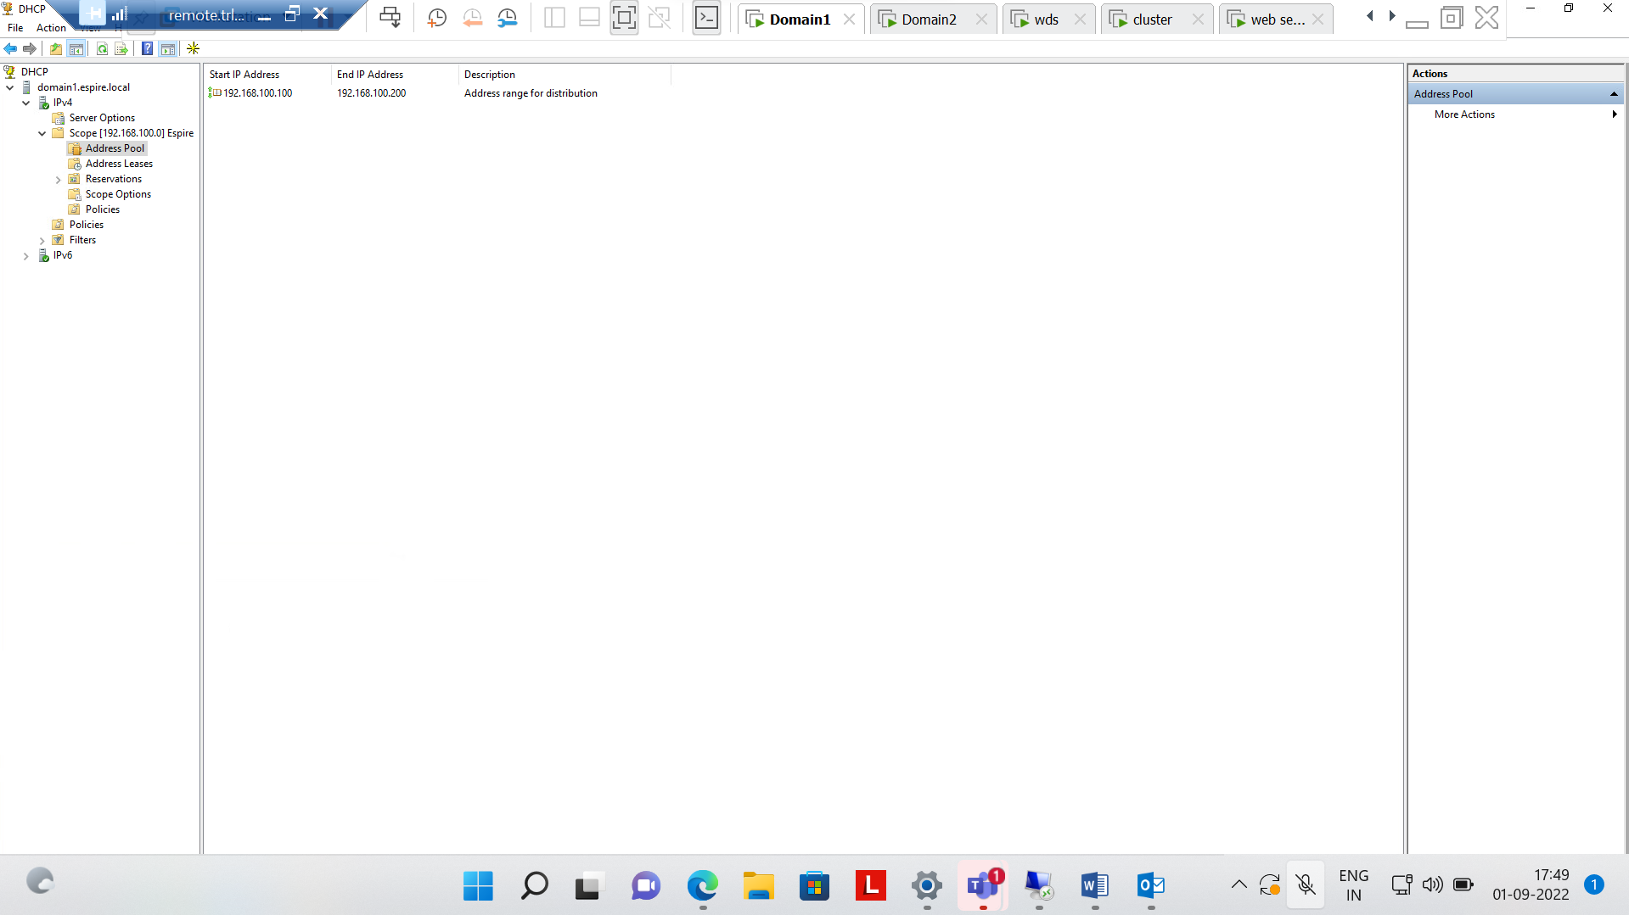

Now add PXE client in scope Options

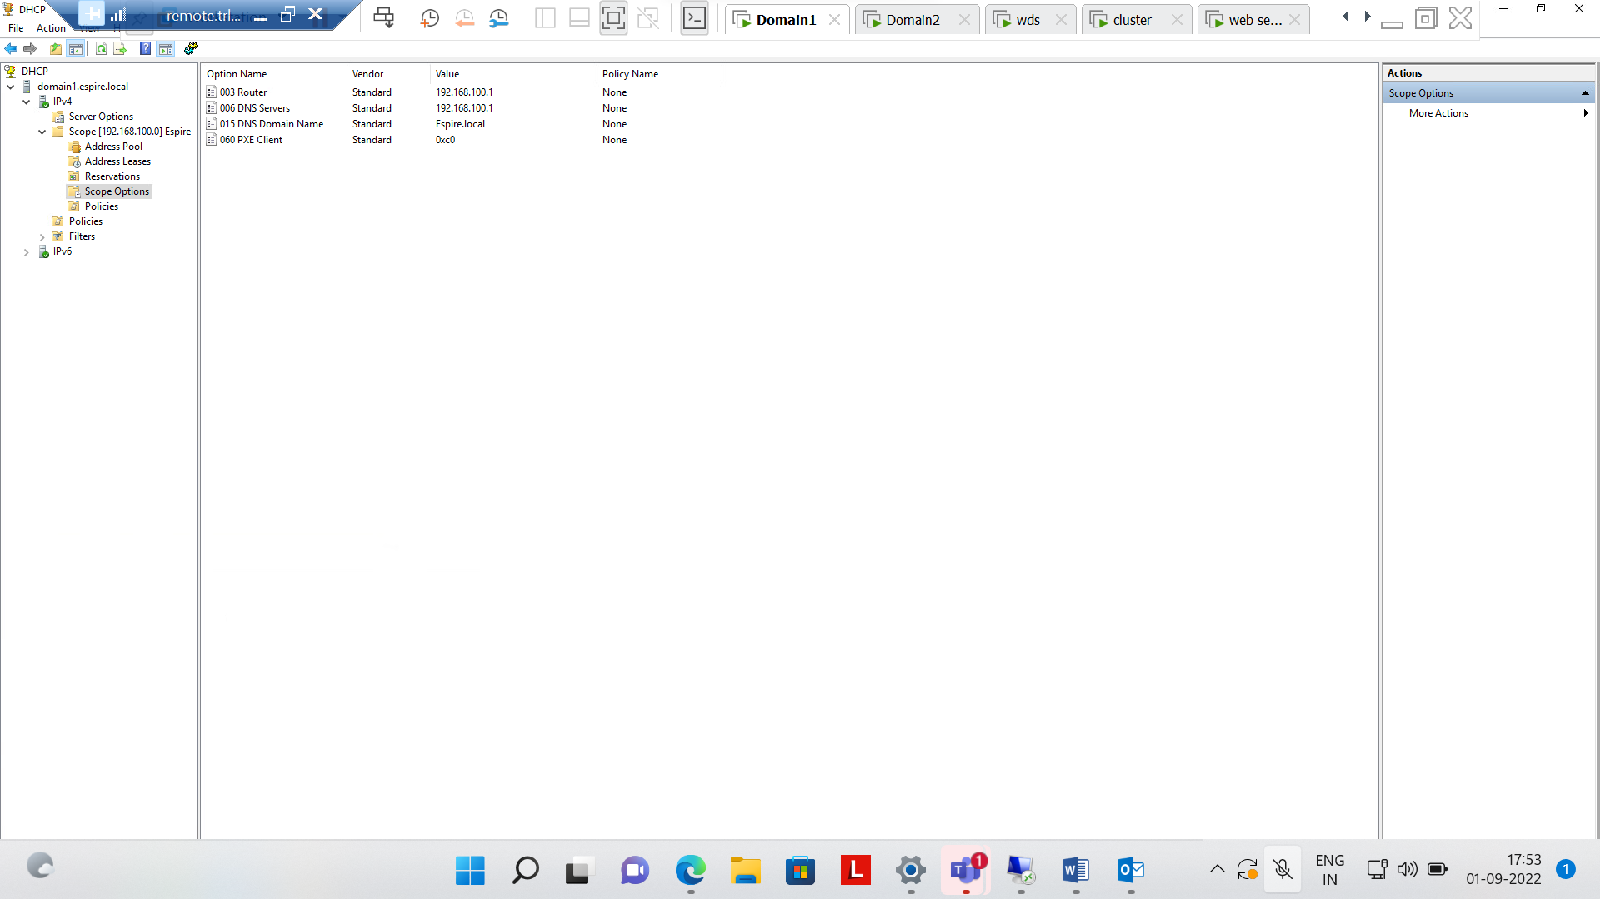

Now Successfully operated installed process

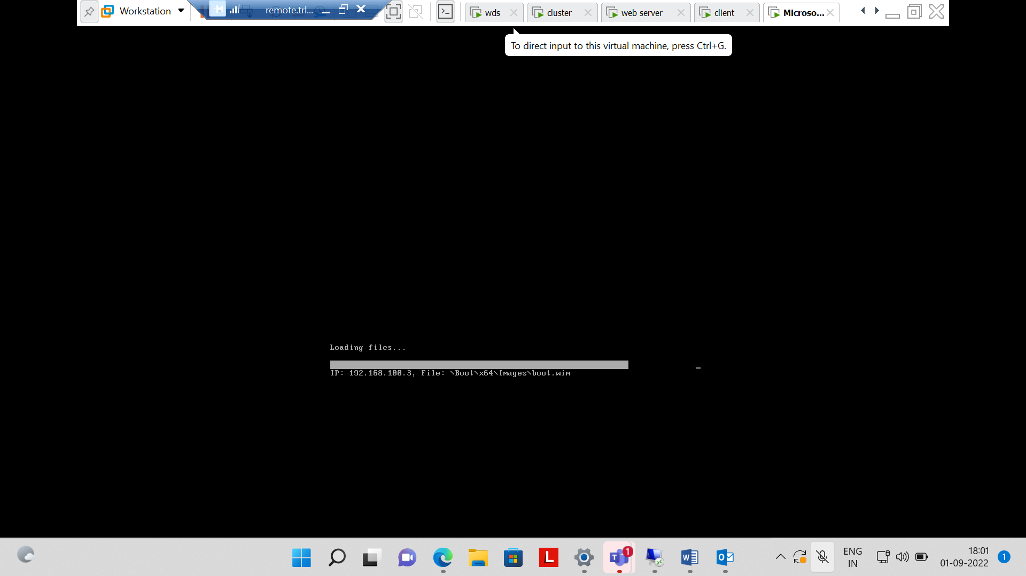

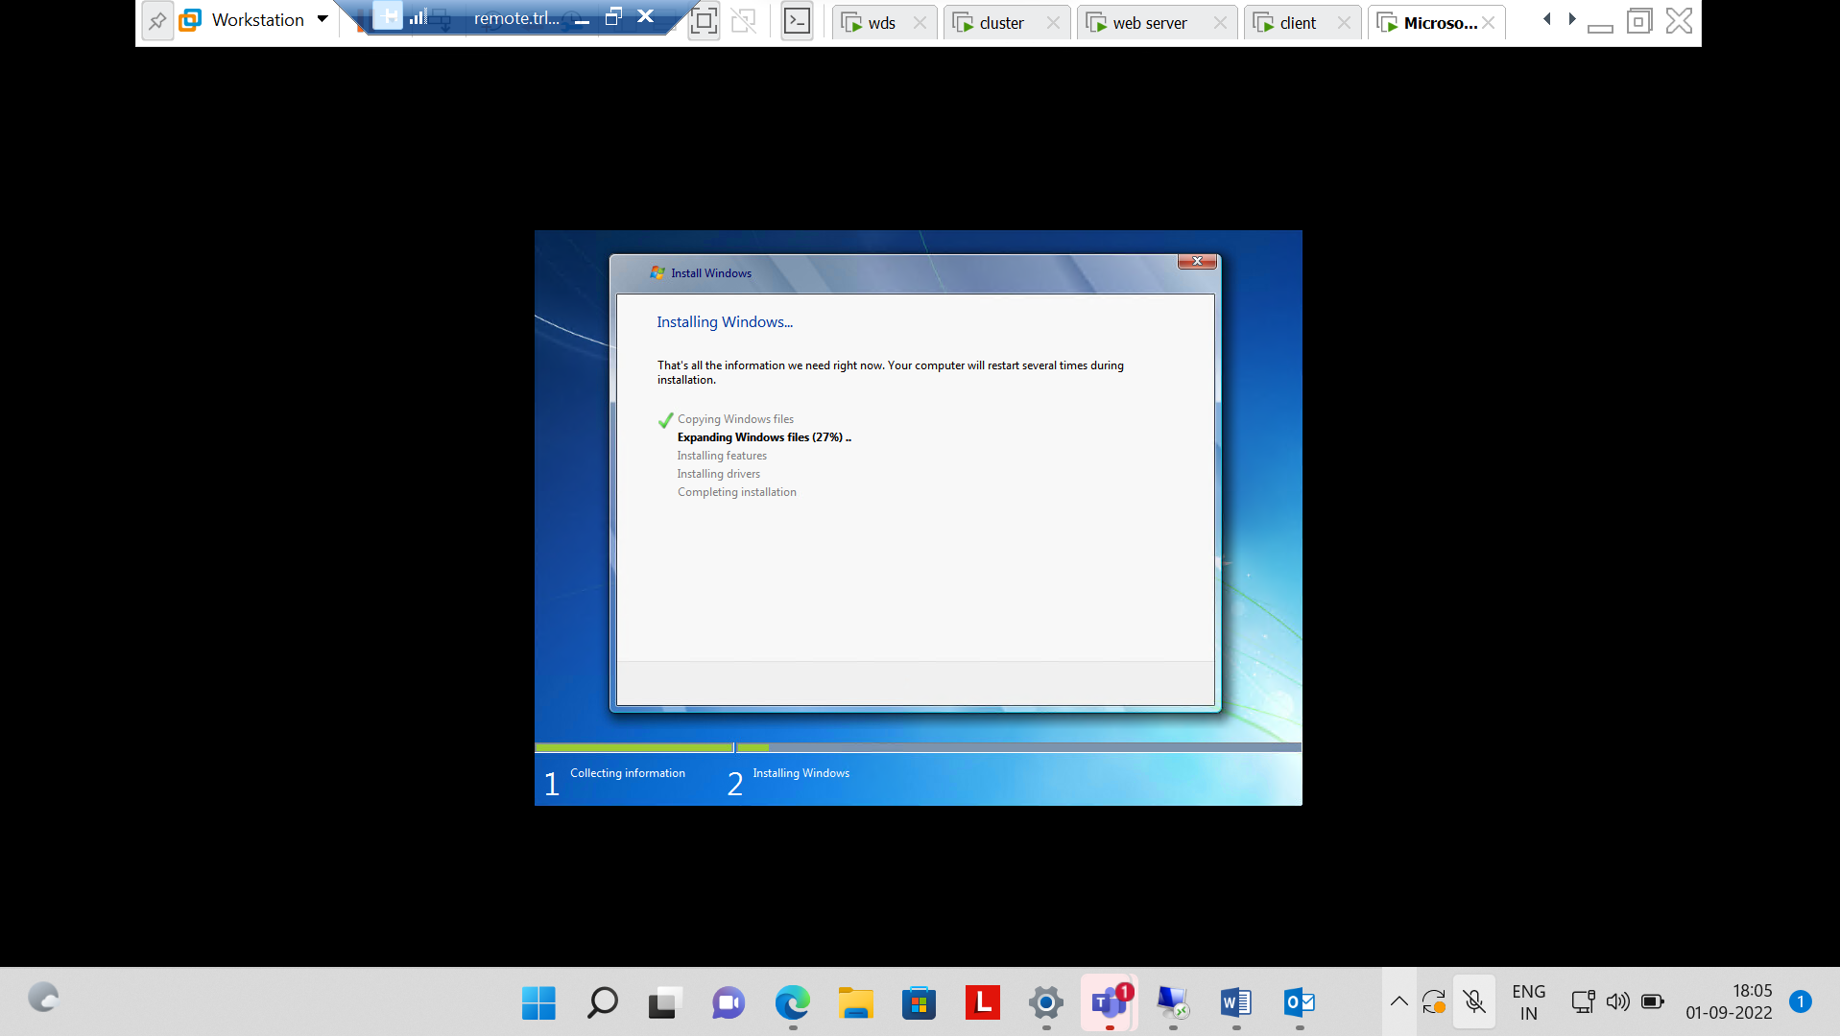

5} Transfer all FSMO roles to the ADC using GUI and transfer back to DC using Powershell. Verify if it worked using command line.

Step1:- Now change the Master role ,RID,PDC,Infrastructure changed to Domain 2 from Domain 1.

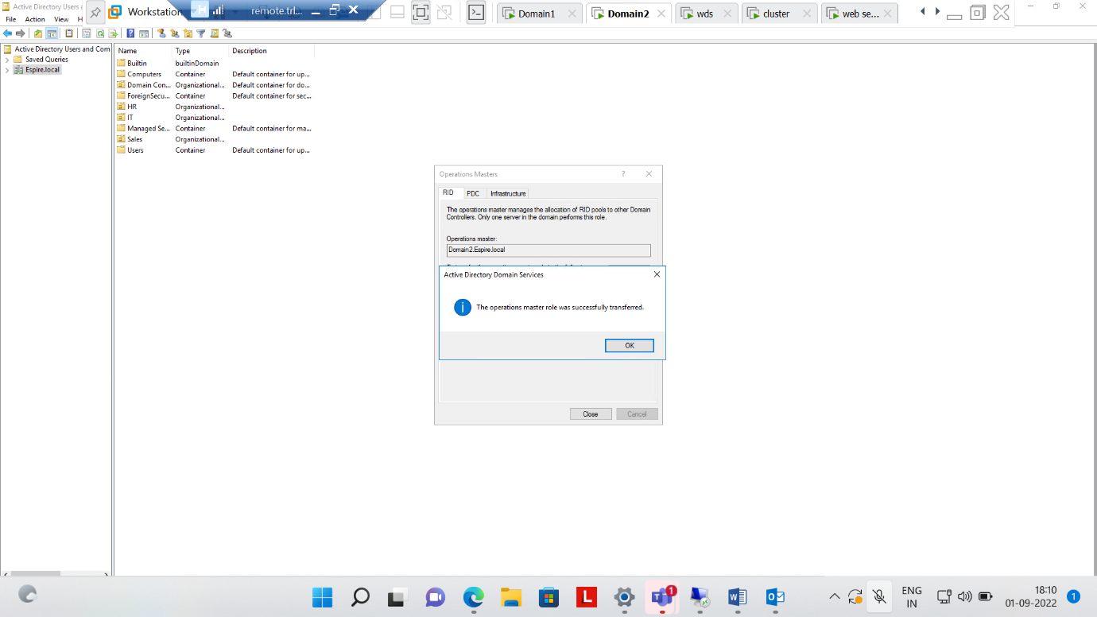  
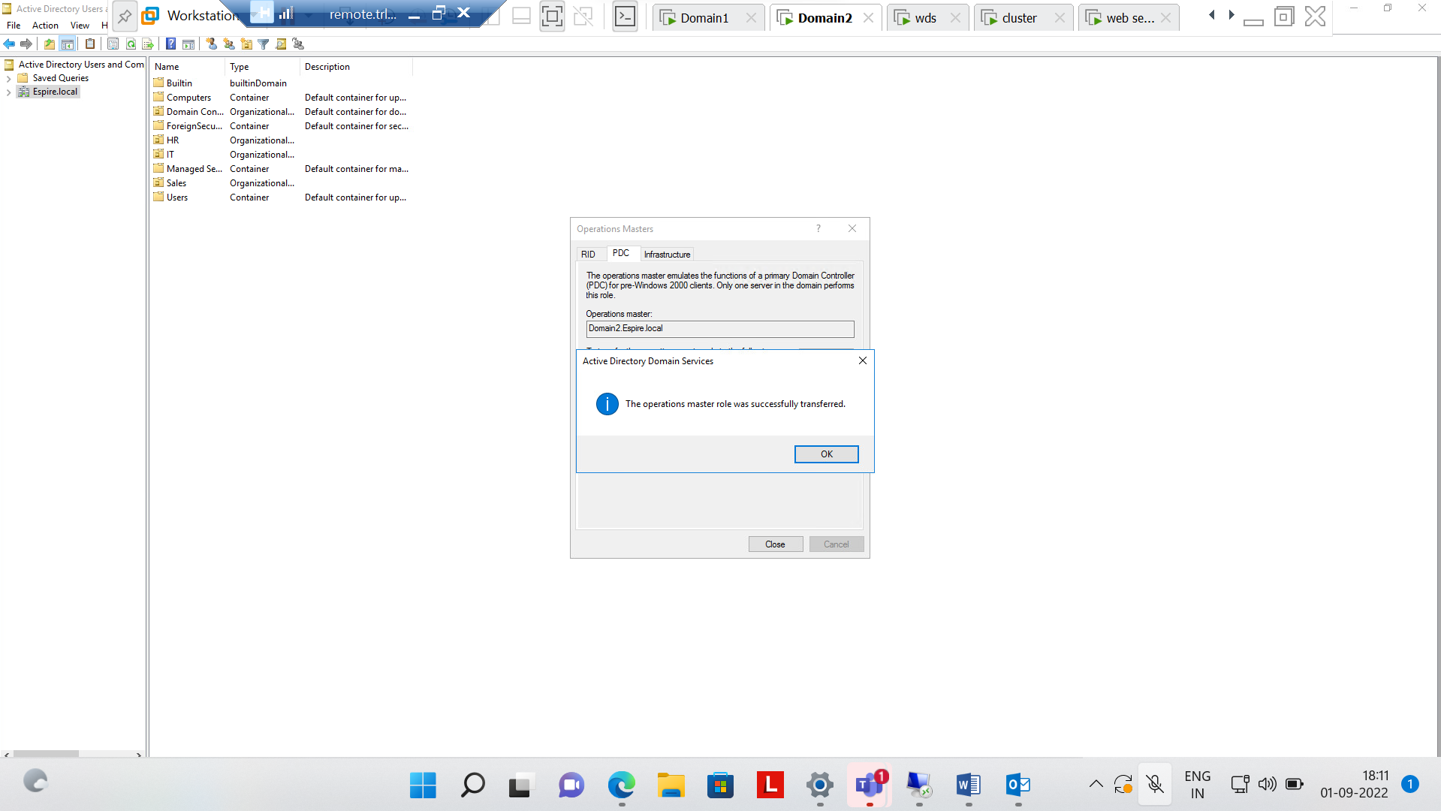

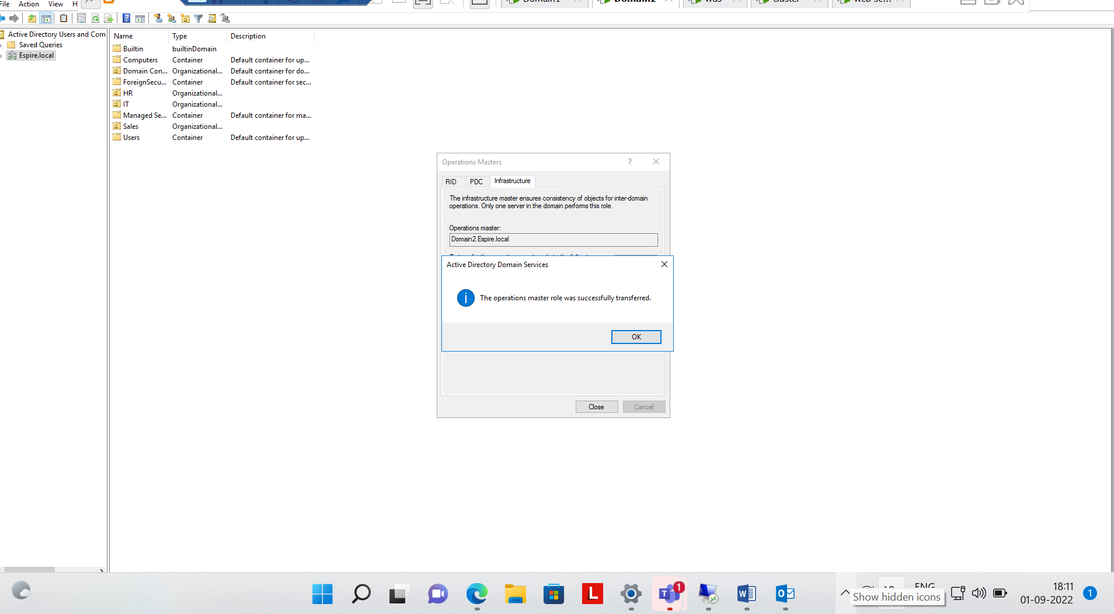

Step 2:- Changed all control and check on cmd

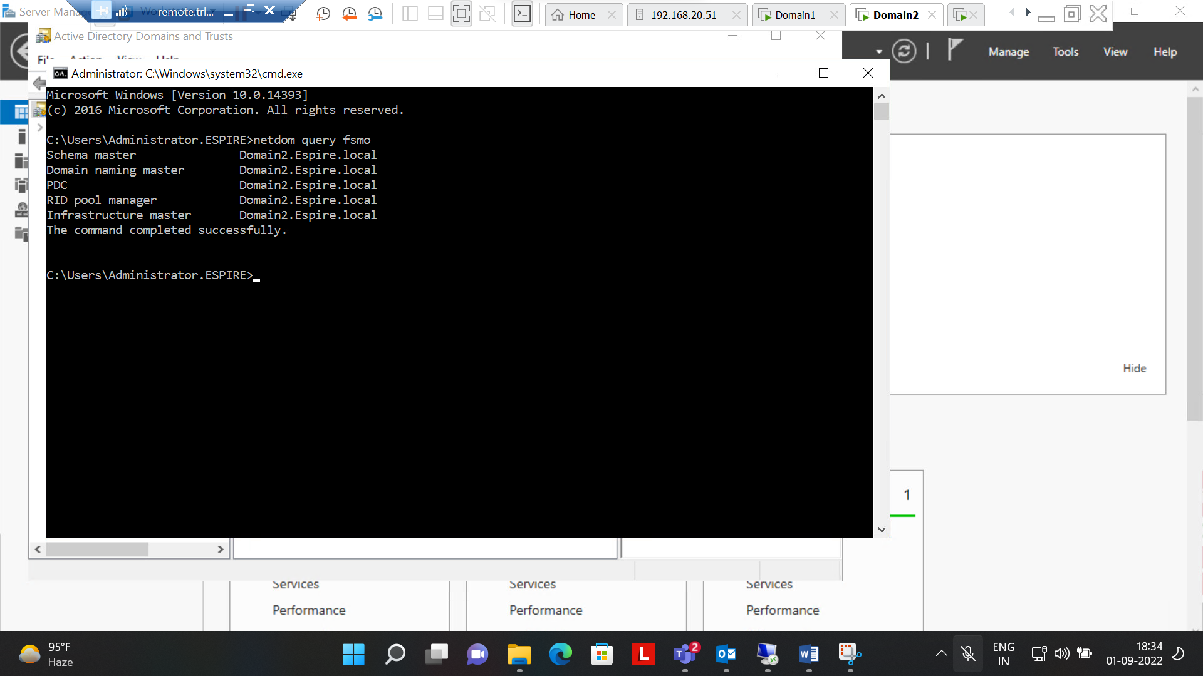

Step3:- Implemented Changing controls to domain 1 from domain 2 using powershell.

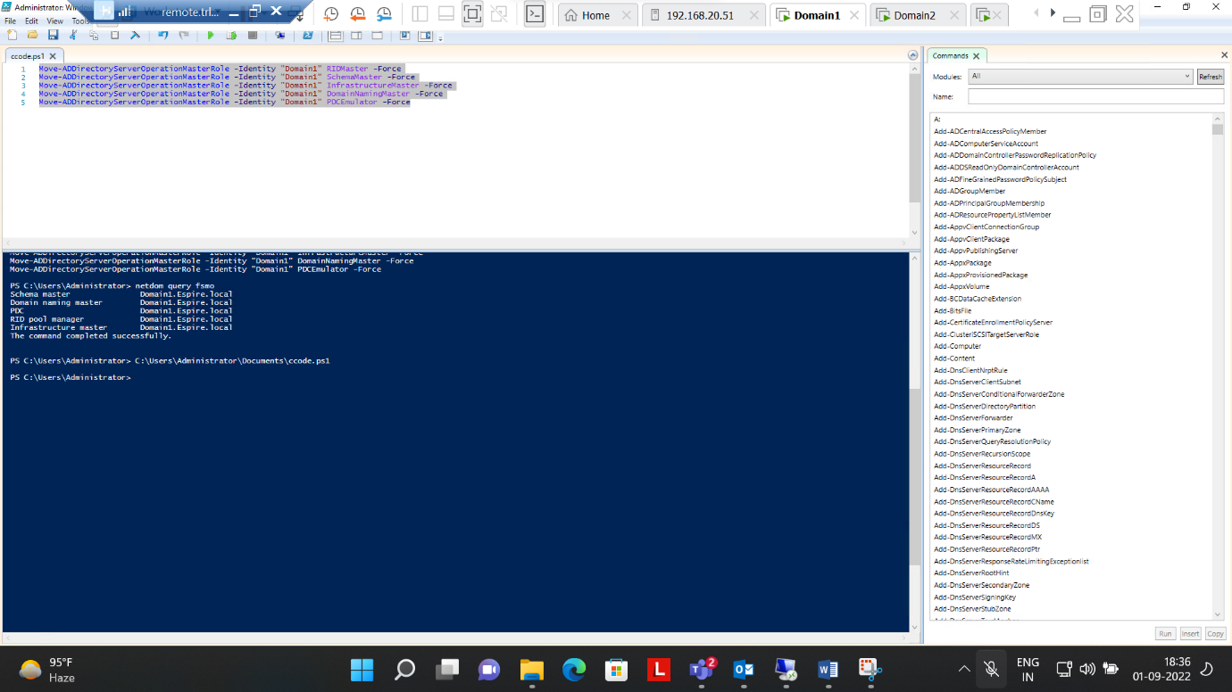

Step 4:- Checked all controls changed to domain 1 from domain 2 using CMD

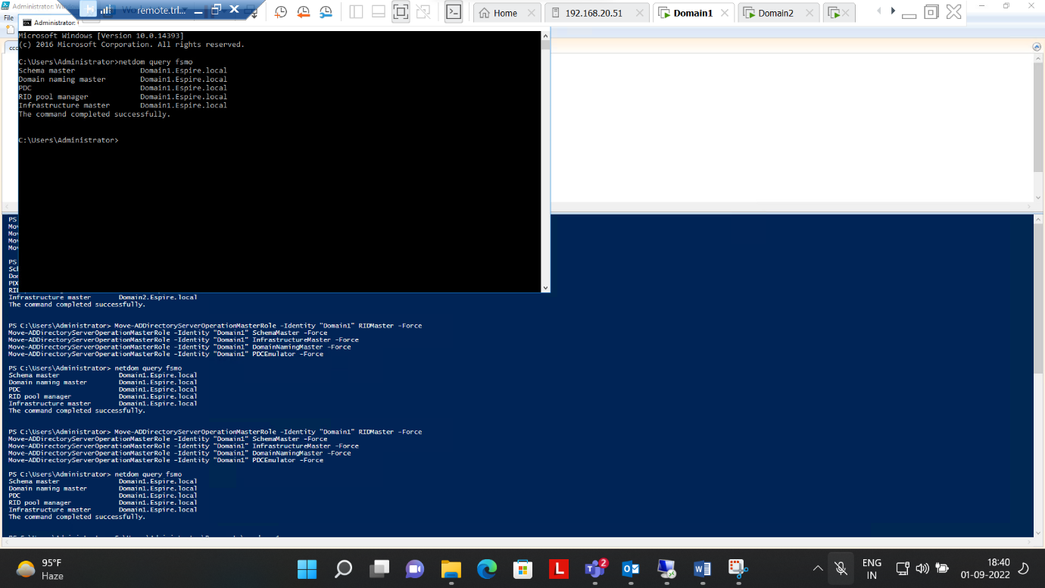

6.Perform installing and Configuring IIS, Create a website with a webpage, Test if it is accessible from the client, protect the Website With SSL

Step 1:- Installed role of Web server(IIS) on both machines i.e. Cluster and web Server

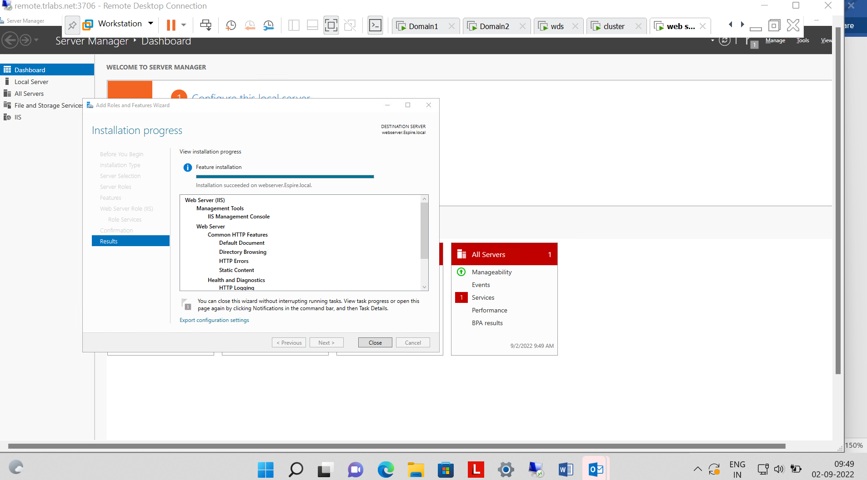

Step 2 :- Installed role of Active Directory Certificate Services in Domain 1

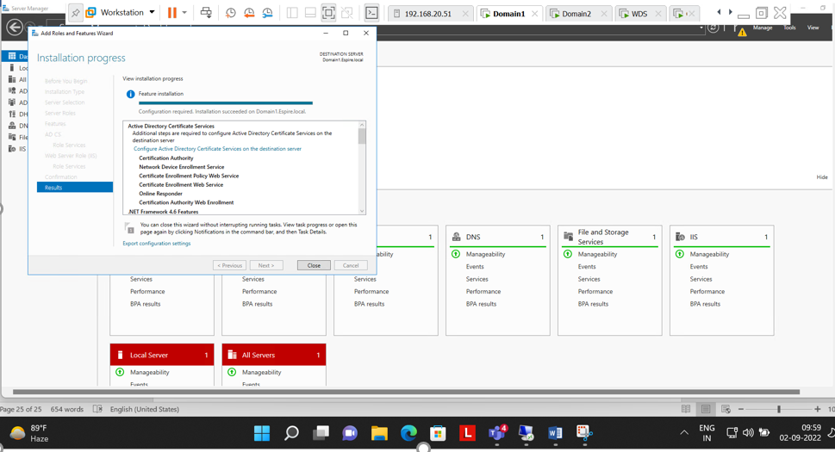

Step 3:- Selected Role Services to configure

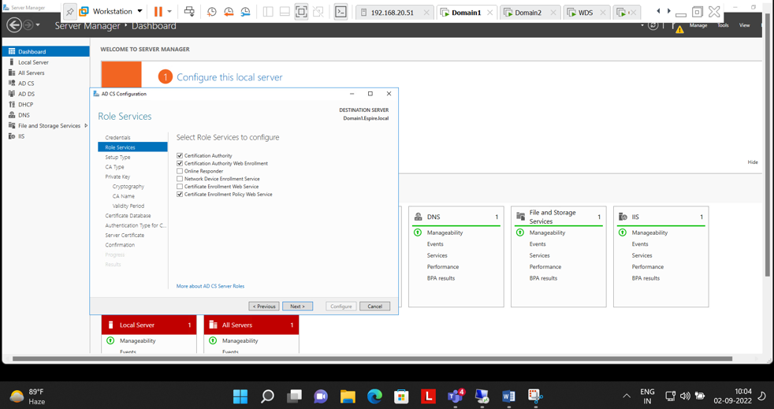

Step 4:- Specified the cryptographic options(SHA512)

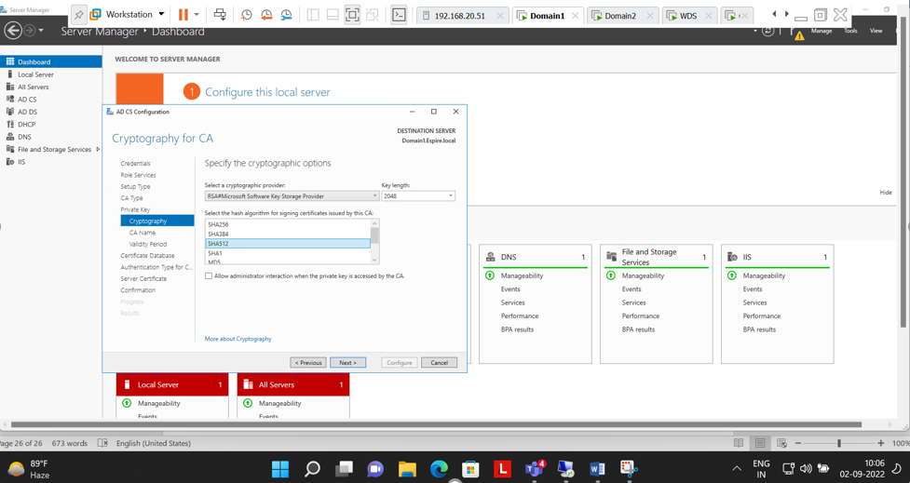

Step 5:- Configuration successful of AD CS

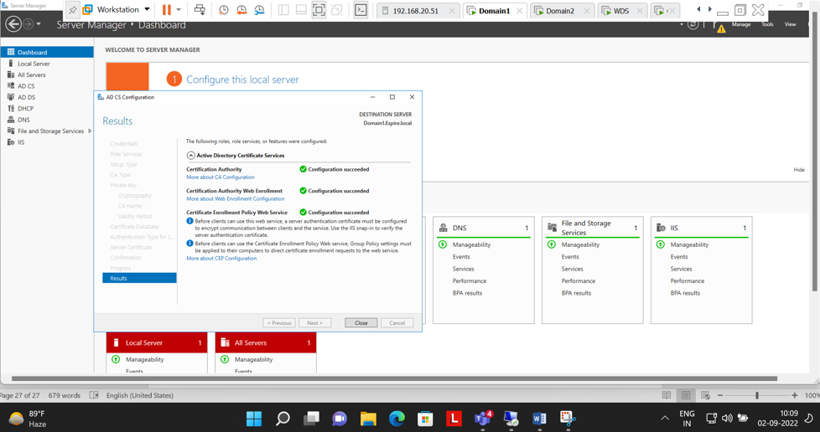

Step 6:- Online Certificate Authority

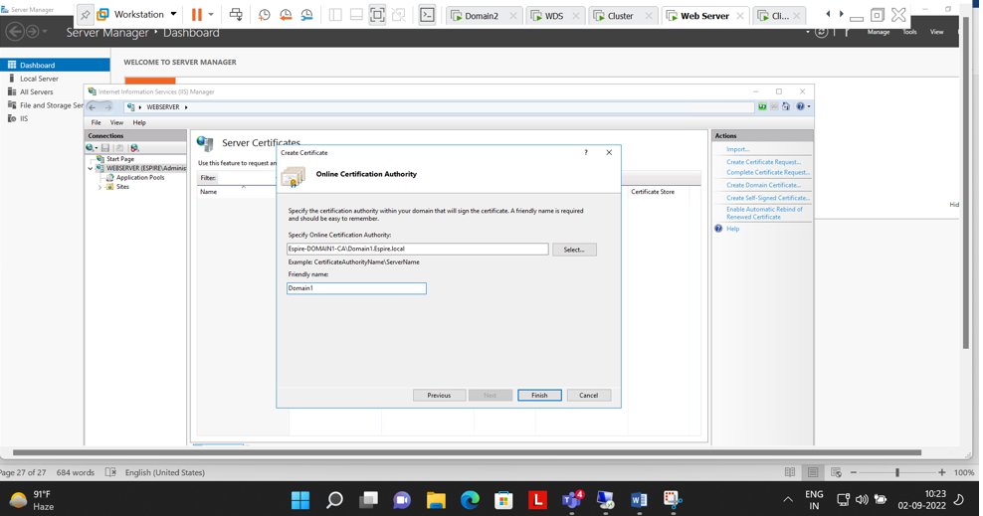

Step 7:- Certificate issued by Domain 1 to webserver

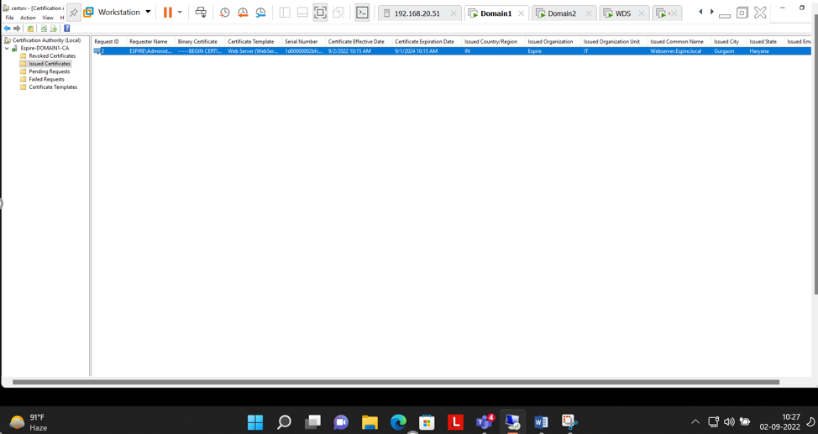

Step 8:- Binding Done in Webserver for(HTTPS)

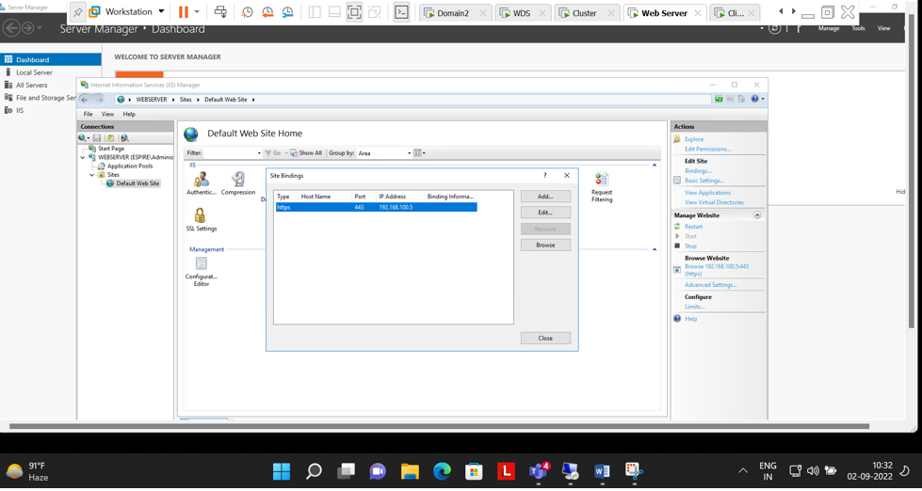

Step 9:- successfully Checked that webserver Site can be accessed from client machine with another user with HTTPS security, i.e. (SSL)

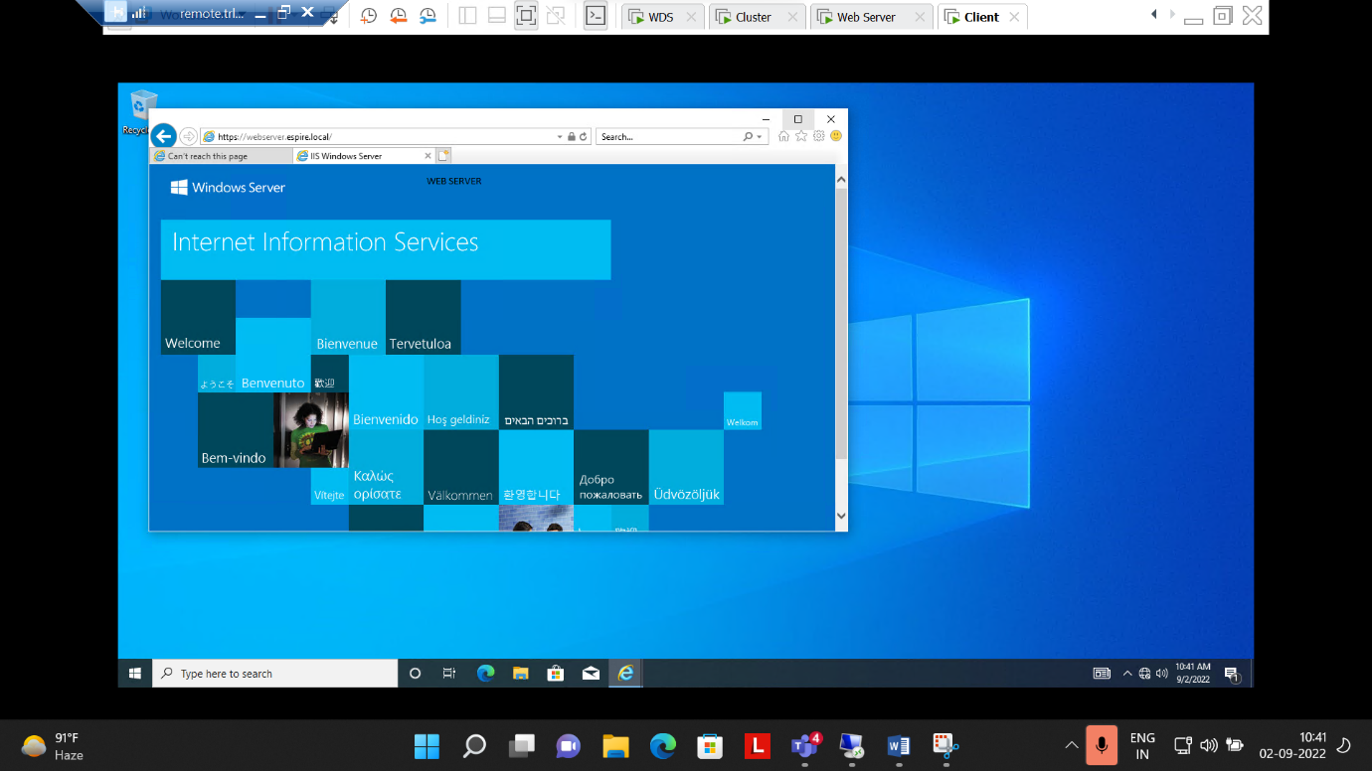

Q.7.Perform installing and Configuring Network load balancing feature , add two web servers and show the result of load balancing when both the web server is on and if one web server is down.

**Ans:-**

Step 1:- Installed Feature of Network Load Balancing in Cluster and Web Server

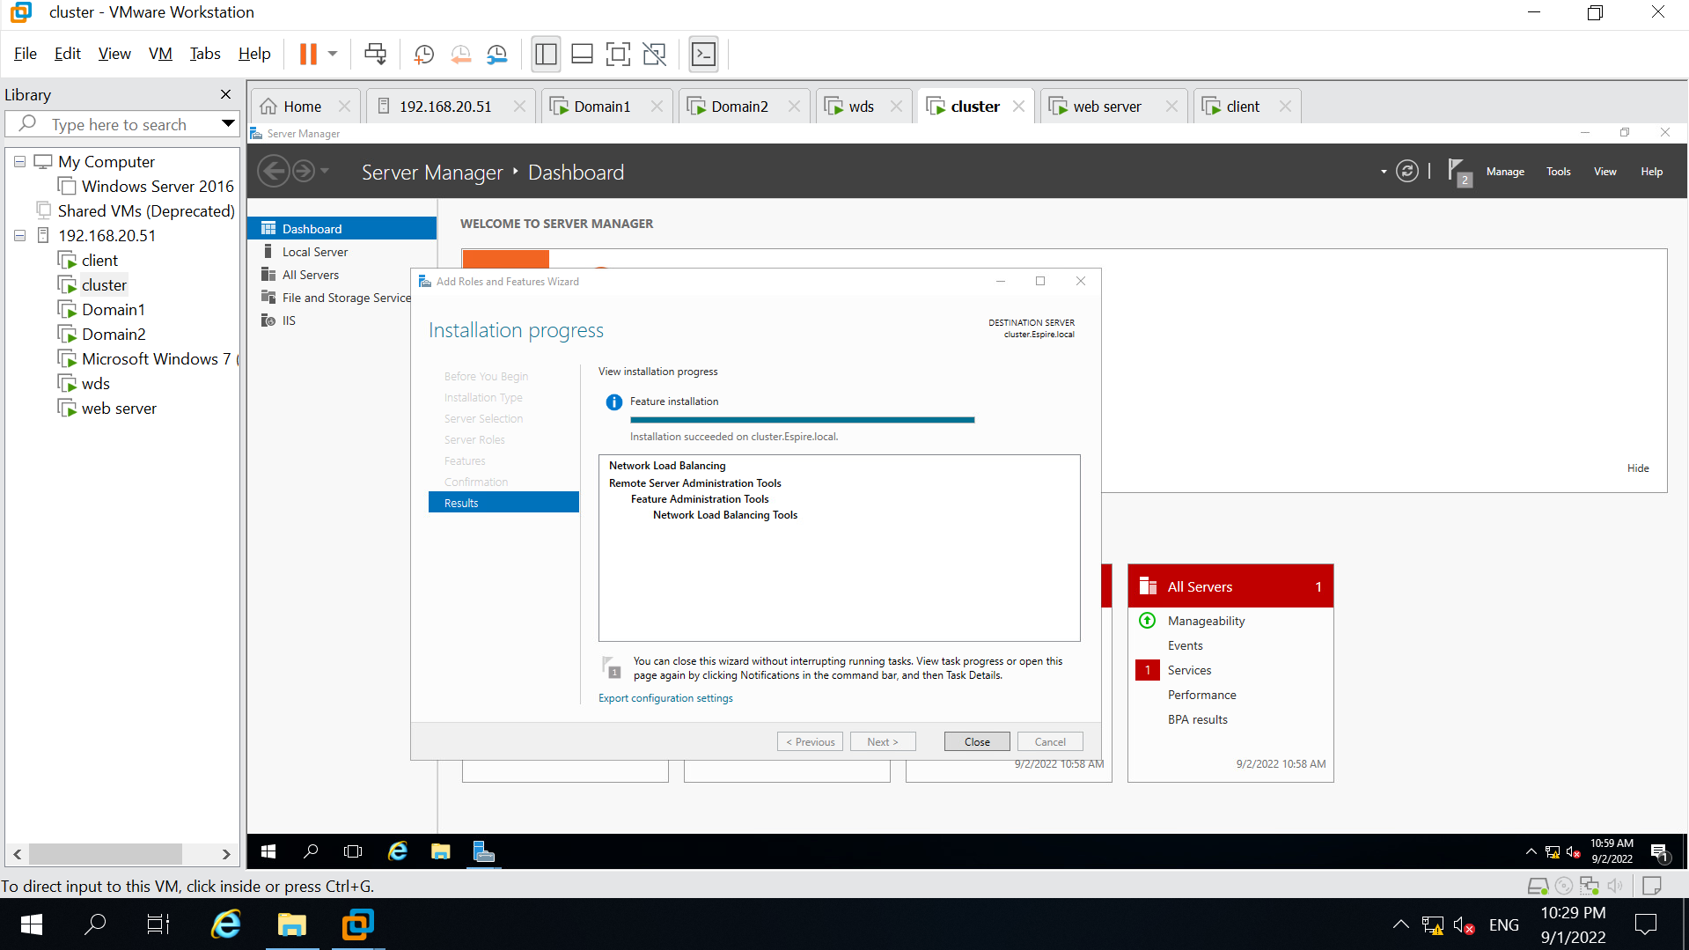

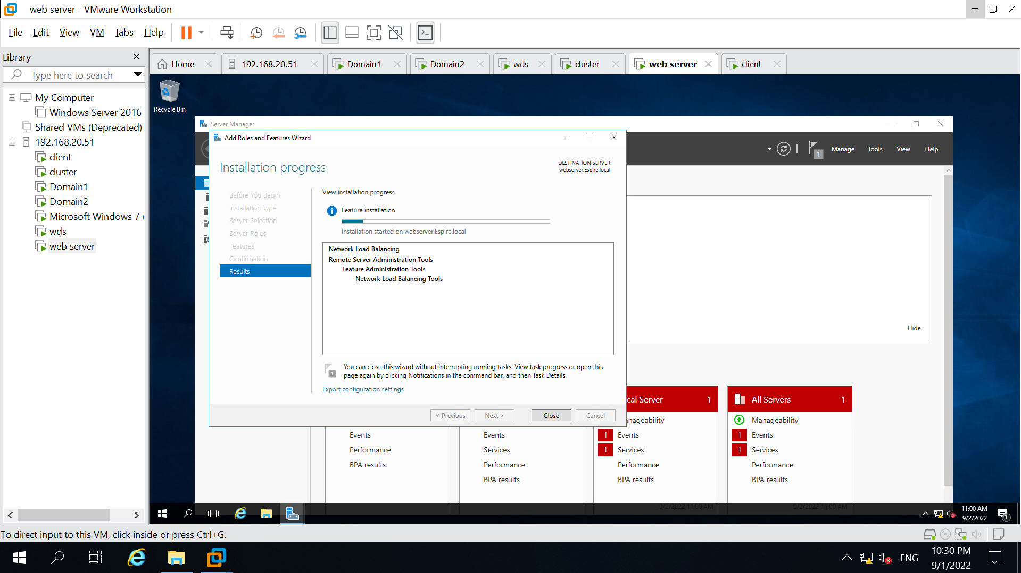

Step 2:- Created Host(A) i.e. 192.168.100.4 , 192.168.100.5 & nlb(192.168.100.55)

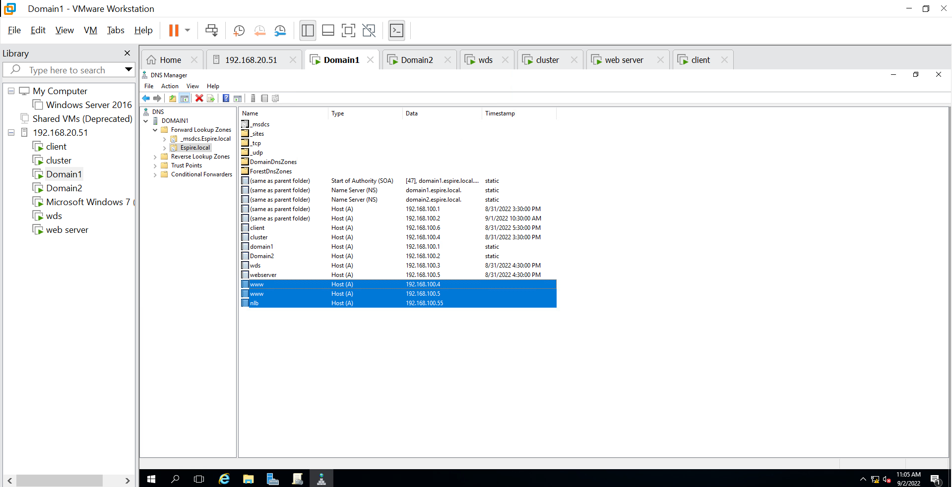

Step3:- Creating new cluster for webserver

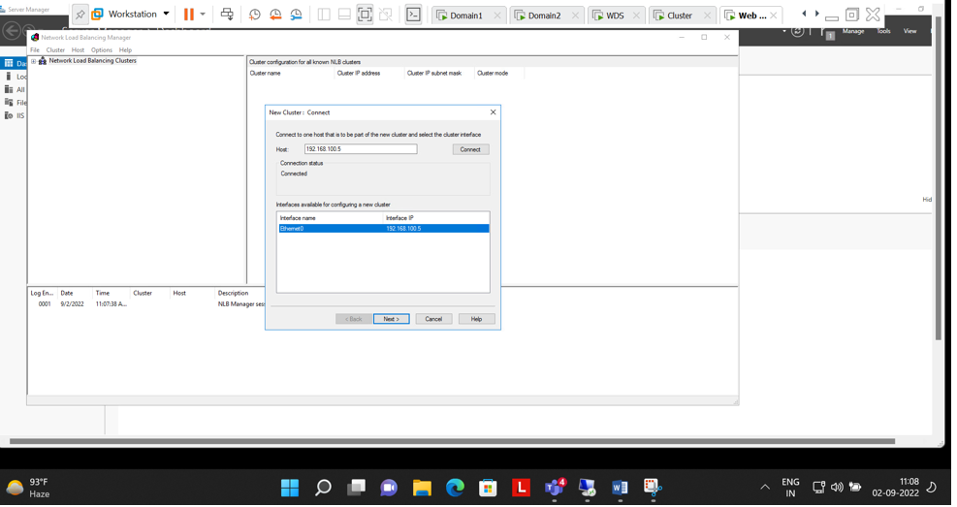

Step 4:-Added the cluster IP address (nlb :- 192.168.100.55)

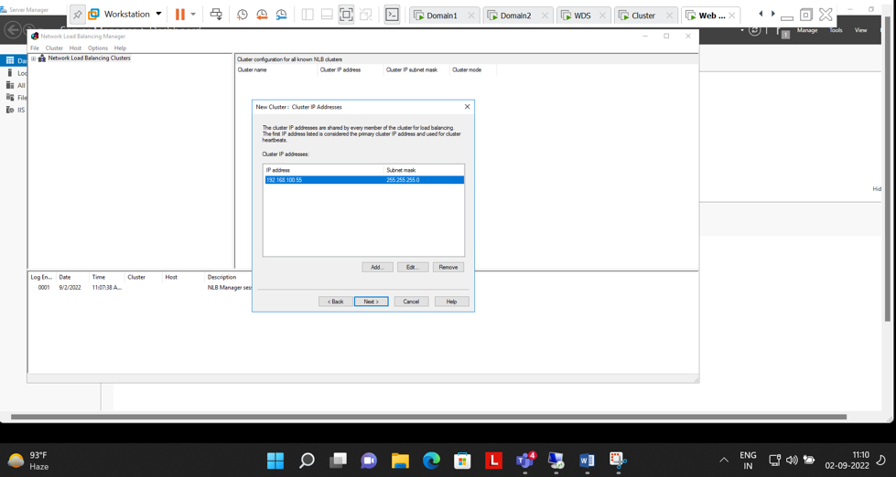

Step 5:- cluster parameter

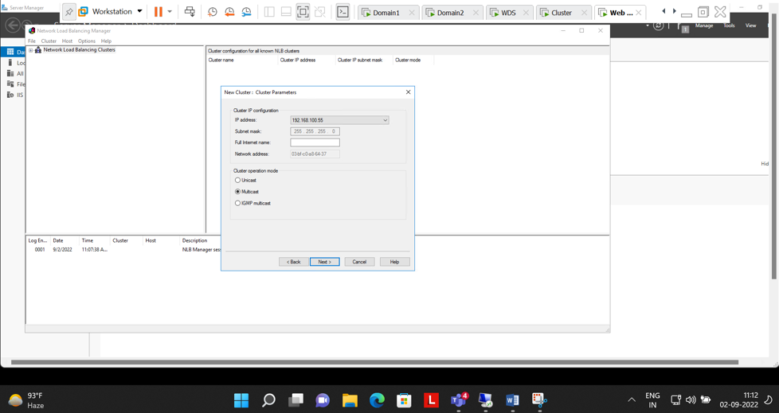

Step 6:- Both The Machines (Cluster & Webserver) are connected with 192.168.100.55(nlb)

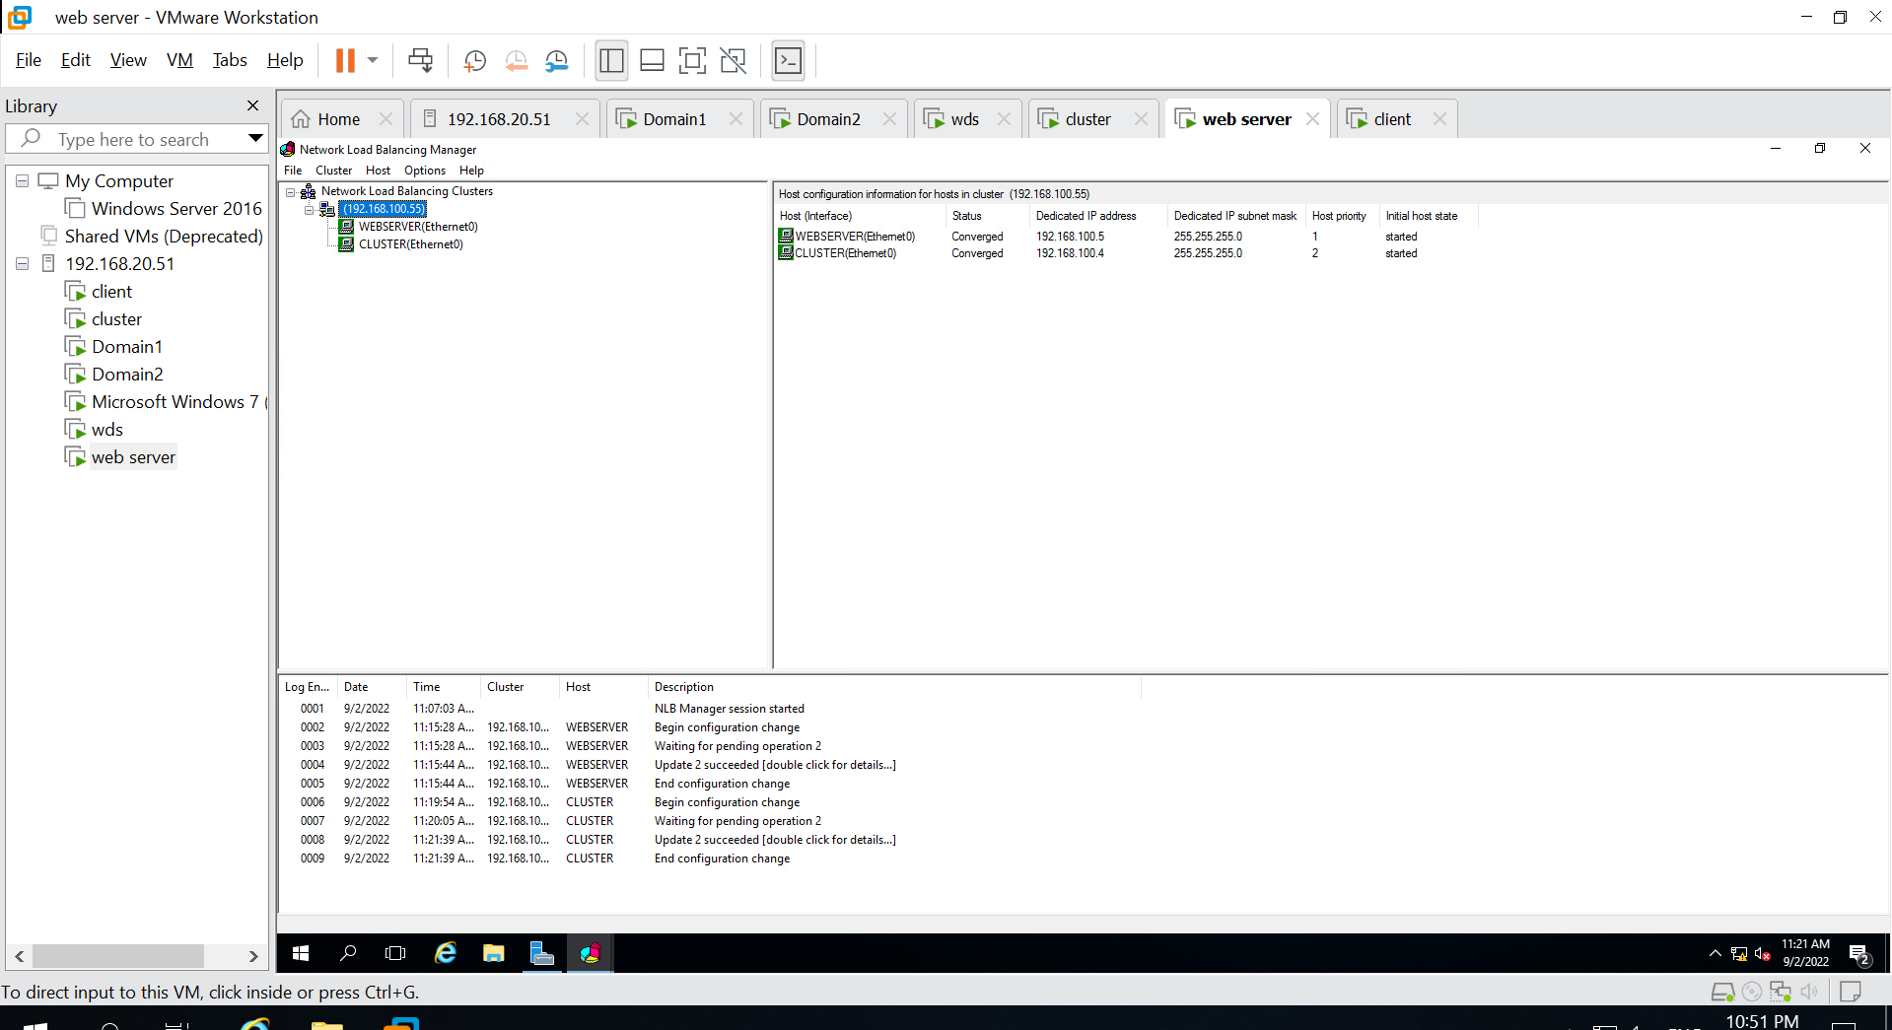

Step 7:- Cluster(192.168.100.4) can be accessed through client

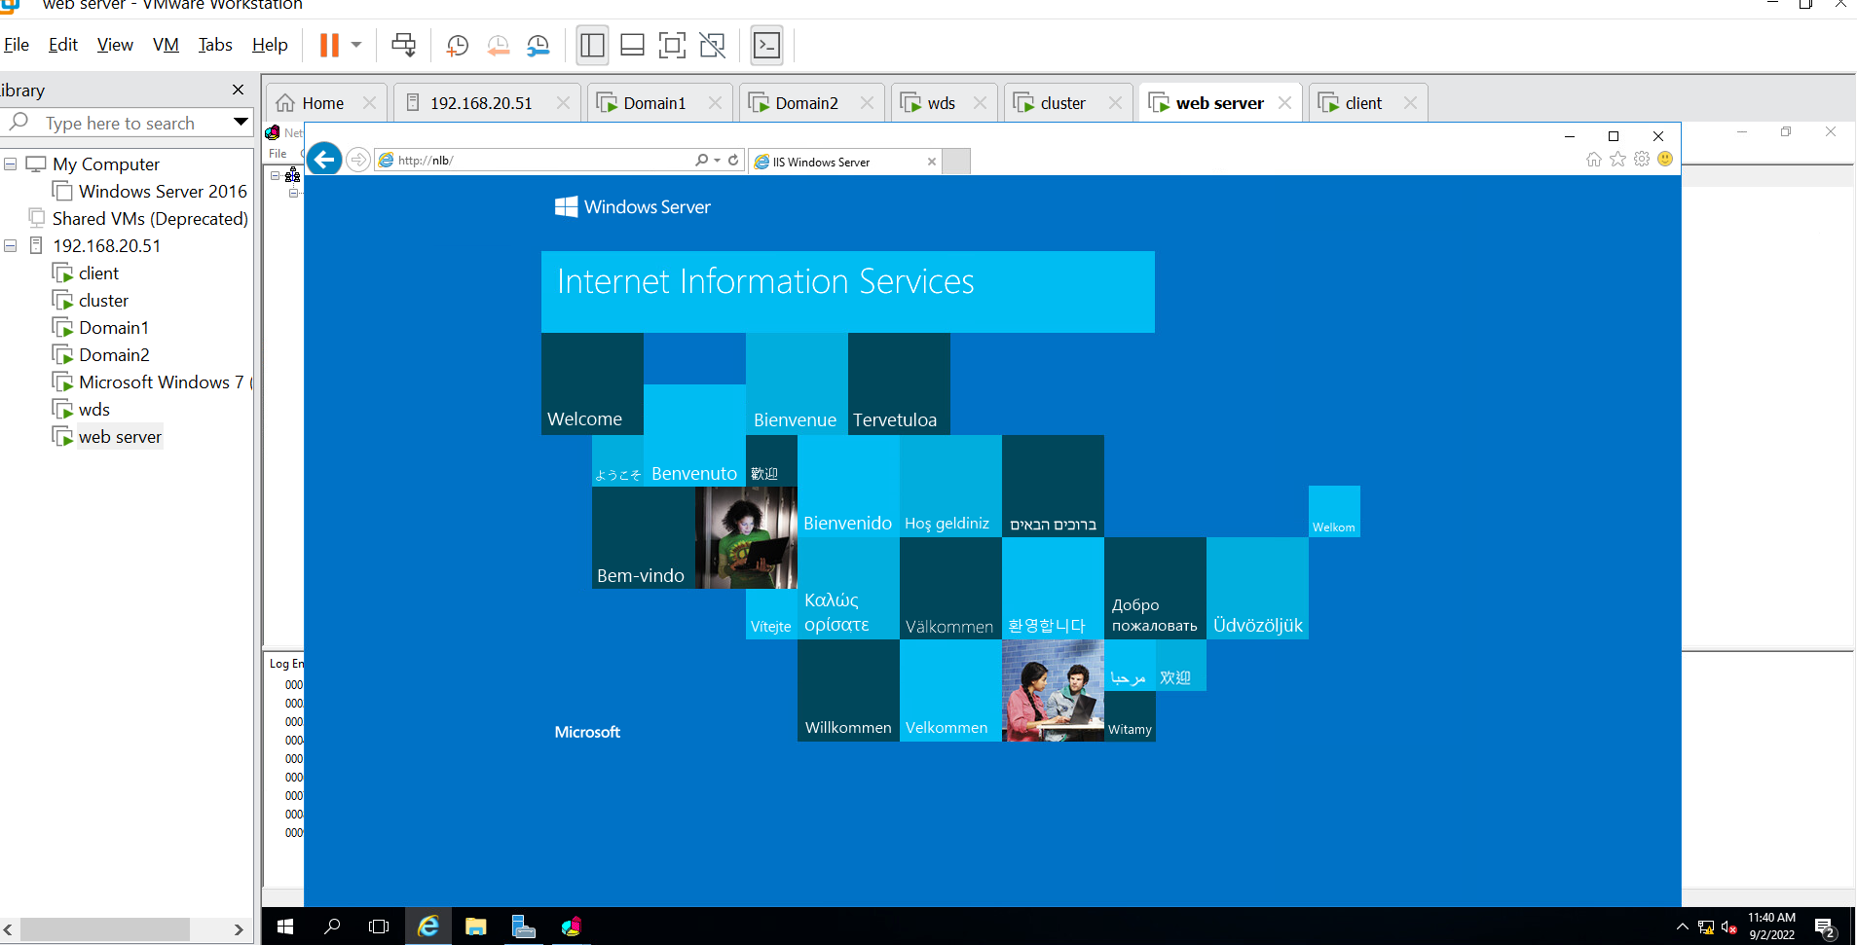

Now shutdown the cluster and check on the client

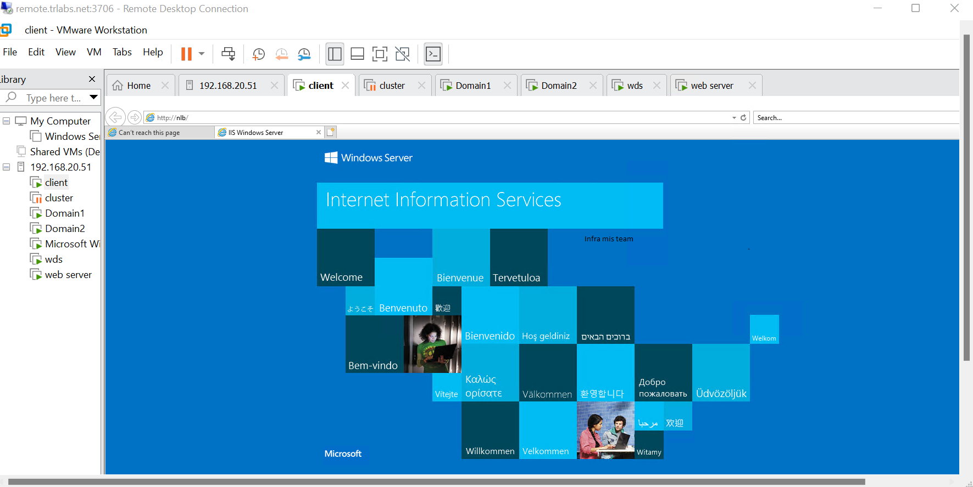

Now Shutdown the web server and check on the client

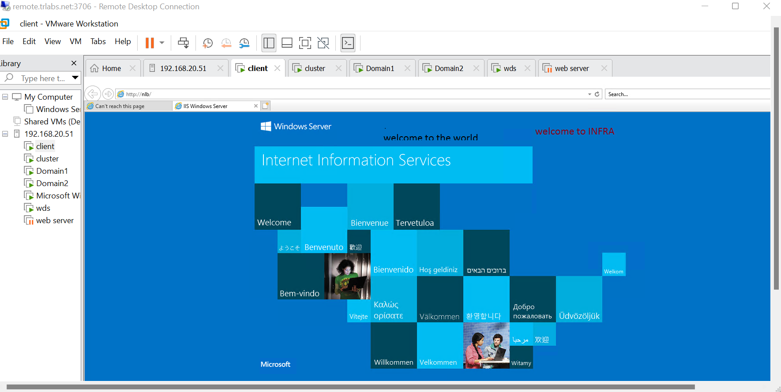

Q8.Implement ADC Replication. Verify if it is working

Ans:-

Step1:- Created new site Gurgaon and usa

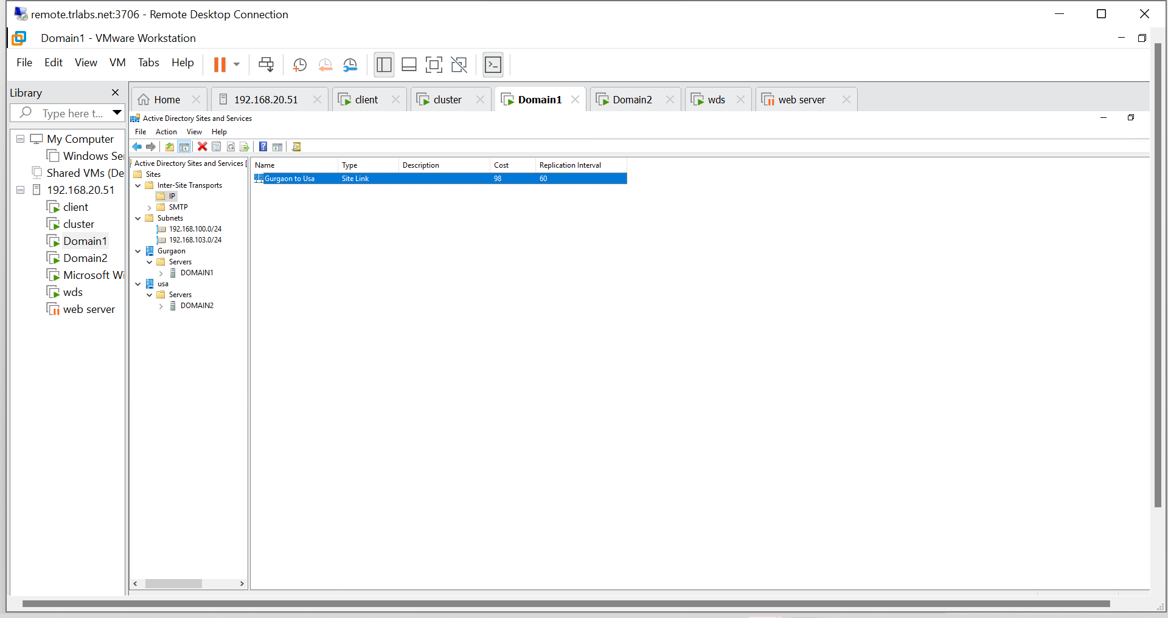

**After that my curser is not working**